

©KinetIQ

Recover Smarter. Play Harder
Jayden Leung | Mack Stewart | Marco Montemurro

39-40 Great Gulf Drive, Concord, Vaughan, Ontario, L4K 5W1
info@kinetiqsports.ca
(416) 844-3510
Website: https://kinetiqsportsnutritionincorperated.base44.app/

© 2025 KinetIQ Sports Nutrition Inc.
No part of this business plan may be reproduced or used in any form or by any means – graphic, electronic, or mechanical – without the prior written permission of the authors.

While every effort has been taken to include accurate and up-to-date information, the authorsrecommend that members of the legal, financial, and business fields be consulted for professional advice before any action is taken.

TABLE OF CONTENTS

1.0 a) Executive Summary -------------------------------------------------------------------------------- 5
1.1 Mission Statement --------------------------------------------------------------------------------------- 5
1.2 Objectives ------------------------------------------------------------------------------------------------- 5
1.3 Company Description ----------------------------------------------------------------------------------- 6
1.4 Product/Service Description --------------------------------------------------------------------------- 7
1.5 Competitive Advantage -------------------------------------------------------------------------------- 10
1.6 Stage of Development ---------------------------------------------------------------------------------- 11
1.7 Proprietary Position ------------------------------------------------------------------------------------ 12
1.8 Financial Requirements -------------------------------------------------------------------------------- 12
2.0 b) Social Impact --------------------------------------------------------------------------------------- 13
2.1 Solution and Impact Proposition --------------------------------------------------------------- 14
2.2 Key Indicators and Evaluation ----------------------------------------------------------------- 15
2.3 Partners and Outreach --------------------------------------------------------------------------- 15
2.4 Inputs and Costs --------------------------------------------------------------------------------- 16
2.5 Funding and Resources ------------------------------------------------------------------------- 17
3.0 Market Analysis -------------------------------------------------------------------------------------- 17
3.1 Industry Analysis ------------------------------------------------------------------------------- 18
3.2 Primary Market Research ---------------------------------------------------------------------- 20
3.3 Market Opportunity ---------------------------------------------------------------------------- 21
3.4 Target Market Profile & Prism Segmentation --------------------------------------------- 22
3.5 Psychographic Insights ---------------------------------------------------------------------- 26
3.6 Customer needs and behaviours------------------------------------------------------------- 27
3.7 Competitive Analysis --------------------------------------------------------------------------- 28
3.8 SWOT Analysis ------------------------------------------------------------------------------- 29
3.9 Marketing Plan -------------------------------------------------------------------------------- 33
3.9.1 Marketing Strategy Overview --------------------------------------------------- 54
3.9.2 Go-To-Marketing Tactic ---------------------------------------------------------- 55
3.9.3 Sales and Distribution Channels ------------------------------------------------ 56
4.0 Resource Analysis ------------------------------------------------------------------------------------ 60
4.1 Management Team ------------------------------------------------------------------------------ 60
4.2 Directors ---------------------------------------------------------------------------------------- 61
4.3 Shareholders ------------------------------------------------------------------------------------- 61
4.4 Valuation Rationale ----------------------------------------------------------------------------- 61
4.5 Professionals Advisors and Consulting--------------------------------------------------------- 63
4.6 Compensation ----------------------------------------------------------------------------------- 64
4.7 Location ----------------------------------------------------------------------------------------- 64
4.8 Facilities and Equipment ---------------------------------------------------------------------- 65
4.9 Technological Resources ---------------------------------------------------------------------- 65
5.0 Operating Strategy ----------------------------------------------------------------------------------- 67
5.1 Staffing and Training --------------------------------------------------------------------------- 67
5.2 Labour Considerations ------------------------------------------------------------------------- 68
5.3 Management Control/Organization Structures ------------------------------------------------ 68
5.4 Manufacturing Plan and Costs ----------------------------------------------------------------- 69
5.5 Suppliers ---------------------------------------------------------------------------------------- 71
5.6 Quality Control --------------------------------------------------------------------------------- 71
5.7 Environmental and Other Issues---------------------------------------------------------------- 71
6.0 Financial Strategy and Projections -------------------------------------------------------------- 72
6.1 Revenue Model and Streams ------------------------------------------------------------------- 72
6.2 COGS, Startup Costs, Operating Costs & Funding Requirements ------------------------------ 73
6.3 Financial Summary and Funding Requested ------------------------------------------------- 77
6.4 Projected Cash Flow Statement ---------------------------------------------------------------- 77
6.5 Projected Income Statement -------------------------------------------------------------------- 79
6.6 Financial Assumptions ------------------------------------------------------------------------- 79
7.0 Proprietary Position & Legal/Regulatory Compliance —------------------------------------ 81
7.1 Intellectual Property Strategy ------------------------------------------------------------------ 81
7.2 Regulatory Requirements (Health Canada) --------------------------------------------------- 82
7.3 Quality Assurance & Certification ------------------------------------------------------------ 82
8.0 Social Impact Strategy ------------------------------------------------------------------------------ 83
8.1 Community Engagement & “KinetIQ for All” Initiative -------------------------------------- 83
8.2 Diversity Equity and Inclusion (DEI) --------------------------------------------------------- 84
8.3 Environmental Responsibility ----------------------------------------------------------------- 84
9.0 Branding and Pricing Strategy -------------------------------------------------------------------- 85
9.1 Brand Identity and Positioning ---------------------------------------------------------------- 86
9.2 Pricing Strategy --------------------------------------------------------------------------------- 86
10.0 Appendices ------------------------------------------------------------------------------------------- 88
10.A Ingredient Composition Per Product Format —------------------------------------------------ 88
10.B Manufacturing and Packaging Cost Break Down Per Product ----------------------------- 88
10.C Product Visuals and Diagrams ---------------------------------------------------------------- 89
10.D Financial Data and Charts -------------------------------------------------------------------- 91
10.E ArcGIS Business Analyst Consumer Demographic Profiling ------------------------------- 93
10.F Full résumé of Business Leaders ------------------------------------------------------------- 94
10.G Acknowledgments ---------------------------------------------------------------------------- 97
10.F KinetIQ Office and Layout -------------------------------------------------------------------- 98

1.0 EXECUTIVE SUMMARY
KinetIQ Sports Nutrition Inc. is a Canadian venture headquartered in Vaughan, Ontario, created to solve a critical and overlooked problem in youth sports: young athletes lack access to safe, scientifically balanced, and enjoyable recovery products. The current market is dominated by adult-formulated supplements and sugary sports drinks that fail to meet young athletes’ physiological needs. KinetIQ fills this gap by offering clean-label, youth-specific recovery solutions—Hydration Mixes, Jelly Sticks, and Recharge Pouches—each designed to support hydration, muscle repair, and inflammation reduction for athletes ages 10–25.

1.1 MISSION STATEMENT
Our mission is simple:
To empower young athletes to recover smarter by delivering clean, science-backed nutrition in fun, accessible formats that make proper recovery effortless and safe.
Our purpose is to help youth perform better, feel stronger, and maintain long-term health through products that meet the needs and wants of today’s young athletes and their families. Guided by values of safety, transparency, education, and performance, KinetIQ promises to provide high-quality recovery solutions that support the physical demands and long-term wellbeing of active youth.

1.2 OBJECTIVES

Short-Term Objectives (0–12 Months)
KinetIQ will build a strong operational foundation by finalizing youth-safe formulations for all three product lines, ensuring they align with clean-label standards and age-appropriate dosing. The company will secure a certified Canadian co-packer capable of NSF or Informed Choice–aligned production to ensure quality and regulatory compliance. Branding, packaging, and educational marketing materials will be developed and tested. KinetIQ will launch a pilot sales program across Ontario schools, academies, and club teams to gather feedback, validate product-market fit, and establish early partnerships.

Medium-Term Objectives (1–3 Years)
The company will transition from early-stage startup to scalable growth. KinetIQ aims to reach break-even through recurring institutional contracts and expanding direct-to-consumer sales. Retail distribution will extend into sporting goods stores, youth athletic clinics, and community sports outlets. Product innovation will continue with seasonal flavours and limited-edition recovery blends based on athlete feedback to strengthen brand engagement and loyalty.

Long-Term Objectives (3-5 Years)
KinetIQ aims to become the leading youth-focused recovery brand in Canada, with expansion into the U.S. market through strategic distribution partners. The company will also develop a digital recovery platform accessible via QR codes on packaging, offering personalized guidance, educational videos, and interactive training tips. This digital integration transforms KinetIQ from a product line into a holistic recovery ecosystem.

1.3 COMPANY DESCRIPTION

Contact Information

Company Name: KinetIQ Sports Nutrition Inc.

Business Address: 39-40 Great Gulf Drive, Concord, Vaughan, Ontario, L4K 5W1

Phone Number: +1 (416) 844-3510

Email Address: info@kinetiqsports.ca

Website: https://kinetiqsportsnutritionincorperated.base44.app/

Background & Business Concept
KinetIQ was developed after observing a widespread challenge among young athletes: fatigue, poor hydration, and inadequate recovery habits caused by ineffective or inappropriate nutrition products. Existing solutions either overshoot (adult supplements with unsafe dosing) or undershoot (high-sugar drinks with minimal recovery benefits). Interviews with athletes, parents, trainers, and coaches confirmed demand for youth-specific, science-backed recovery products. KinetIQ’s clean-label, age-appropriate formulations and fun delivery formats directly address this problem.

Start-Up Date & Location
KinetIQ plans to launch operations in Spring 2026, headquartered in Vaughan, Ontario, with manufacturing outsourced to a certified Canadian co-packer.

Ownership Structure
KinetIQ operates as a partnership jointly owned by the three founders. This structure enables shared expertise, flexible decision-making, and reduced administrative complexity. Although partners share liability and profit division, the arrangement supports agility and collaboration—essential in early venture development.
The company is founded as a partnership, allowing the three co-founders to combine diverse expertise, share responsibility, and make agile decisions during early growth. While partnership structures come with shared liability and profit division, they offer speed, flexibility, and collaborative strength—ideal for KinetIQ’s development stage.

Key Management Personnel
KinetIQ is led by a complementary and capable management team (see full résumés in Appendix).
Mack Stewart — Chief Executive Officer (CEO) & Chief Financial Officer (CFO)
Jayden Leung — Chief Operating Officer (COO) & Chief Technology Officer (CTO)
Marco Montemurro — Chief Marketing Officer (CMO) & Chief Product Officer (CPO)
Together, the KinetIQ leadership team balances vision, operational strength, financial discipline, technological capability, creative branding, and scientific product development—a foundation engineered for long-term success in the youth sports nutrition market.

1.4 PRODUCT/SERVICE DESCRIPTION
KinetIQ provides a comprehensive, youth-focused recovery system designed to solve the most common and most harmful gaps in young athletes’ post-activity routines. Today, youth athletes rarely consume the nutrients required for proper recovery. Many rely solely on water—or nothing at all—after intense practices or games, neglecting critical needs such as electrolyte replenishment, muscle repair support, and inflammation control. This leads to extended fatigue, slower performance improvements, and significantly higher injury risk; for example, dehydration alone causes muscle fatigue and joint instability, increasing susceptibility to sprains and strains.
The core issue is that existing recovery products are not built for kids. Adult supplements (like protein powders, BCAAs, creatine blends, or pre-workouts) are dosed for adults and can be unsafe or unappealing for young athletes. Youth products (like sports drinks) address only hydration and often contain large amounts of sugar. As a result, there is no clean, convenient, all-in-one recovery solution designed for ages 10–25.
KinetIQ directly solves this problem with a recovery product line formulated around the three scientifically validated pillars of youth athletic recovery:

Hydration
Electrolytes including sodium, potassium, and magnesium restore fluid balance, regulate nerve function, and support muscle contractions.

Muscle Repair

Protein-building amino acids—BCAAs, glutamine, or youth-appropriate collagen peptides—support muscle recovery, reduce microtears, and aid growth during adolescence.

Inflammation Control
Natural anti-inflammatory and antioxidant ingredients such as turmeric extract, tart cherry, vitamin C, and vitamin D help manage soreness and support joint health.
All three pillars are combined in a single serving, eliminating the need for multiple products (sports drink, protein bar, vitamins). Kids only need one KinetIQ product after activity to meet core recovery needs.
Just as importantly, KinetIQ solves the behavioral compliance problem. Kids frequently avoid or forget recovery routines when products taste bad, are time-consuming, or feel medicinal. KinetIQ is engineered to be enjoyable—tasty flavours, fun textures, and youth-friendly formats—so athletes want to take it consistently. Compliance is often the missing piece in recovery nutrition, and KinetIQ solves it through format innovation.

KinetIQ Product Line
KinetIQ launches with three complementary product formats, each designed to deliver the same core recovery benefits while appealing to different preferences:

Hydration Mixes
A flavoured powder that mixes with water to create a refreshing, low-sugar post-workout drink.
Key Features:
- Broad electrolyte profile (sodium, potassium, magnesium)
- Amino acids such as BCAAs and glutamine
- Immune and recovery vitamins (C, B-complex, D)
- Zero added sugar; sweetened naturally (monk fruit/stevia)
- Dissolves quickly in any water bottle
- Safe, youth-appropriate dosing
This is ideal for athletes already accustomed to using water bottles post-practice.

Fruit-Flavoured Jelly Sticks (KinetIQ Jellies)
A squeezable gel-based recovery snack similar to applesauce or fruit purée.
Key Features:
- Electrolytes + amino acids
- Natural fruit flavours and pectin-based plant formulation
- Turmeric or tart cherry for inflammation control
- No artificial dyes (colour from plants)
- Portable, fun, and easy to consume
This format is especially appealing to younger athletes and improves compliance dramatically.

Recharge Pouches
A GoGo-Squeeze–style purée designed for complete on-the-go recovery.
Key Features:
- Micro-dosed creatine (youth-safe levels) for energy metabolism
- Carbohydrates to replenish glycogen
- Antioxidants for inflammation reduction
- Smooth, easy-to-digest texture
- This is ideal right after a game or tournament when convenience is essential.

Quality & Safety Standards
KinetIQ is built around youth safety first. Every formulation:
- Contains youth-appropriate dosing only
- Avoids caffeine, stimulants, and adult-strength ingredients
- Is gluten-free and school-safe
- Minimizes sugar content
- Uses clean-label flavours, colours, and sweeteners
Manufacturing is conducted through Canadian co-packers with NSF/Informed Choice–aligned production standards. The company plans to pursue NSF Certified for Sport to reassure parents and coaches that products contain exactly what is listed and no banned substances.

1.5 COMPETITIVE ADVANTAGE
KinetIQ holds a clear competitive edge through four key innovations:

Multi-Format Delivery System
Most brands offer only one format (powder or ready-to-drink). KinetIQ provides three distinct formats all delivering the same recovery benefits. This increases accessibility and compliance while creating a customizable recovery experience.

All-in-One Youth-Safe Recovery
Hydration + muscle repair + inflammation control in one serving.
Most competitors focus solely on hydration or protein—not both together, and never tailored for kids.

Kid-Centric Taste, Texture & Education
KinetIQ intentionally looks, tastes, and feels like a treat.
Plus, QR-coded Recovery Education teaches stretching, nutrition, and hydration habits—something no competitor offers.

First-Mover Advantage In the Youth Market
KinetIQ is one of the first brands built exclusively for ages 10–25.
This niche is large, underserved, and increasingly prioritized by parents, coaches, and health professionals.

1.6 STAGE OF DEVELOPMENT
KinetIQ is currently in the advanced concept and early prototype stage. The core formulations for each product format (hydration mix, jelly stick, and recharge pouch) have been developed at a laboratory level, and early-stage ingredient ratios have already been tested for safety and youth-appropriate dosing. Branding, packaging concepts, and serving-size formats have been created, and the digital “Recovery Education” platform framework is in place. KinetIQ has also identified several Canadian co-packers capable of producing youth-safe nutritional products under NSF or Informed Choice–aligned standards.
At this stage, KinetIQ has:
- Detailed formulations and product specifications
- Prototype packaging designs
- Preliminary jelly and hydration formula samples
- Identified suppliers and manufacturing partners
The next steps include:
- Producing full-scale flavour prototypes for product testing with youth athletes
- Conducting shelf-stability and safety testing
- Finalizing commercial formulas
- Completing certification and regulatory filings
- Ordering first production runs and packaging
Photographs of packaging prototypes and sample formulations will be included in the Appendix once finalized. Additional costs required for completion include commercial flavour development, packaging print runs, co-packer deposits, and stability testing expenses.

1.7 PROPRIETARY POSITION
KinetIQ will pursue trademarks for its brand name, product names, taglines, and packaging. The company will comply with all Health Canada Natural Health Product (NHP) regulations and will select a co-packer with NSF or Informed Choice–aligned certifications. KinetIQ products will undergo required standardized testing for safety, stability, and quality compliance. All necessary permits and regulatory filings will be obtained prior to production and distribution.

1.8 FINANCIAL REQUIREMENTS
KinetIQ’s total project cost to launch and sustain operations through Year 1 is $377,000 CAD, consisting of $210,679 CAD in one-time startup expenses and $166,132 CAD in first-year operating costs. Startup costs cover product development, regulatory certifications (including NPN and NSF testing), prototype manufacturing, initial inventory, co-packer deposits, packaging, e-commerce infrastructure, marketing launch activities, and essential equipment. Operating costs include production runs, insurance, licensing fees, fulfillment, advertising, rent, utilities, and staffing.
Funding sources will include $25,000 CAD in founder investment, approximately $325,000 CAD through an angel investment round, and an estimated $20,000 CAD from grants, youth entrepreneurship programs, and pre-order or crowdfunding initiatives. These combined sources ensure that total project funding equals total project costs, maintaining financial viability and meeting business plan requirements.
KinetIQ projects reaching profitability by Year 3, supported by high-margin direct-to-consumer sales, strong subscription retention, and recurring institutional contracts with schools, clubs, and sports organizations.
Conclusion
KinetIQ offers a timely, differentiated, and high-potential solution to an underserved market. With its clean-label products, mission-driven vision, strong leadership team, technology-enabled education, and scalable operations, KinetIQ is positioned to become the premier recovery brand for young athletes across Canada and beyond.

2.0 SOCIAL IMPACT

Problem
Across Canada, many young athletes lack access to proper recovery education and safe, youth-appropriate nutrition. This disproportionately affects athletes in underfunded communities, where cost, limited resources, and lack of health knowledge create barriers to safe training and participation in sport.
Children impacted by this challenge often:
- Experience preventable injuries due to dehydration and poor recovery habits
- Skip essential nutrition because they cannot afford clean, healthy options
- Have limited awareness of how to care for their bodies
- Lose motivation or drop out of sports because recovery barriers make training harder
Why it matters:
Poor recovery habits at a young age can lead to long-term health issues, increased injury risk, and reduced access to the benefits of sport—confidence, community, physical activity, and mental wellbeing. Addressing this issue helps build healthier youth and stronger communities.

Beneficiaries and Vision
Beneficiaries include:
- Young athletes ages 10–25
- Parents lacking access to affordable, safe nutrition
- Low-income or underfunded sports teams, schools, and clubs
- Coaches seeking tools to keep athletes healthy and engaged
Vision:
KinetIQ aims to create a future where every young athlete—regardless of income, background, or location—has access to proper recovery education and youth-safe nutrition. Our long-term goal is to improve wellness literacy, reduce preventable sports injuries, and support wider participation in youth athletics.

2.1 SOLUTION AND IMPACT PROPOSITION
KinetIQ’s solution addresses both the nutritional gap and the educational gap in youth sports.

Our idea:
To provide clean, all-in-one recovery products that make proper nutrition simple and enjoyable, and to pair them with accessible digital recovery education for athletes, parents, and coaches.

Specific tasks required:
- Produce safe, youth-formulated recovery products
- Create free, accessible “Recovery Education” videos via QR codes on packaging
- Develop community partnerships with schools and underfunded teams
- Run workshops, clinics, or online learning modules
- Donate products or provide subsidized pricing for youth in need

How beneficiaries are impacted:
- Young athletes recover faster, stay healthier, and learn proper wellness habits
- Coaches experience fewer injury-related absences
- Parents feel confident in safe, affordable nutrition
- Underserved communities gain access to resources they could not previously afford

2.2 KEY INDICATORS AND EVALUATION
To evaluate impact, KinetIQ will track:
Key Indicators:
- Number of youth athletes reached through education
- Reduction in reported dehydration- or fatigue-related issues among partner teams
- Participation rates in subsidized or donated product programs
- Engagement with QR-linked recovery modules
- Feedback from coaches, parents, and athletes
Measurement & Evaluation:
- Quarterly surveys of partner teams
- Tracking digital engagement analytics
- Before-and-after assessments of recovery habits
- Monitoring injury reports where data is available
- Coach and parent testimonials
This ensures that our social initiatives are not symbolic—they create measurable improvements.

2.3 PARTNERS AND OUTREACH
Potential partners:
- Schools, sports academies, and community clubs
- Youth centers and after-school programs
- Non-profit sports organizations (e.g., Jumpstart, KidSport)
- Physiotherapists, trainers, and youth sports coaches
- Municipal recreation departments
How we will work with partners:
- Provide subsidized or donated recovery products
- Offer educational workshops or digital modules
- Support fundraising tournaments and community events
- Collaboratively evaluate athlete wellness improvements
Targeting and reaching beneficiaries:
- Direct outreach to school athletic departments
- Partnerships with coaches’ associations
- Social-media-based education campaigns
- Collaborations with youth sports influencers

2.4 INPUT AND COSTS
Resources required to accomplish the impact plan:
- Product manufacturing allocated for donation programs
- Educational content creation (videos, infographics, website modules)
- Outreach staffing or volunteer ambassadors
- Packaging with QR-coded educational links
- Transportation for delivering donated product
Additional costs due to social mission:
- Reduced margins for subsidized products
- Costs of producing free educational materials
- Value of donated product inventory
- Partnership administration and field outreach costs
These are built into KinetIQ’s long-term sustainability strategy.

2.5 FUNDING AND RESOURCES
Can beneficiaries pay for part of the solution?
In many cases, yes; standard consumers will purchase products normally. However, underserved communities will receive subsidized pricing or donated goods through the “KinetIQ For All” initiative.
Funding sources include:
- Sales revenue from full-price customers
- Grants supporting youth health and sport accessibility
- Sponsorships from larger athletic brands or local businesses
- Community fundraising events (clinics, tournaments, merch)
- Partnerships with school boards or non-profit organizations
Additional resources leveraged:
- Volunteer athletes and ambassadors
- Digital content (which scales with low cost once created)
- Community coaches promoting recovery education
- Networking through school partnerships and tournaments
These resources allow KinetIQ to maximize impact while managing cost efficiency.
Summary
KinetIQ is not only a sports nutrition brand—it is a youth wellness initiative. By improving recovery literacy, increasing access to safe nutrition, and supporting underfunded athletes, KinetIQ strengthens communities and promotes long-term health equity. Our mission ensures that every young athlete—regardless of income or location—can perform, grow, and thrive with the support they deserve.

3.0 MARKET ANALYSIS

Youth sports in Canada are growing rapidly, with athletes training harder, competing more frequently, and facing higher physical demands than ever before. Yet the sports nutrition industry has not evolved to meet the needs of this demographic. Most products are aimed at adults, contain unsuitable doses of active ingredients, or rely heavily on sugar. Parents, coaches, trainers, and athletes consistently report a lack of recovery solutions that are safe, functional, enjoyable, and designed specifically for youth.

KinetIQ directly addresses this gap by delivering clean, science-backed recovery products optimized for athletes aged 10–25.
Please see Appendix A for GIS Market Research Results

3.1 INDUSTRY ANALYSIS

The sports nutrition market in Canada is growing rapidly, driven by increased health awareness, wider acceptance of supplements, and higher participation in both recreational and competitive sports. Despite this momentum, the youth athlete segment remains largely overlooked, with few established brands offering products designed specifically for under-18 athletes. This gap is especially notable given the high participation and consistent hydration needs of young athletes. Globally, demand is also shifting toward more targeted hydration and recovery solutions, creating an ideal opportunity for a youth-focused brand like KinetIQ to enter the market with limited direct competition and strong long-term potential.

Key Industry Trends

Several macro-trends in 2025 strongly support KinetIQ’s market entry:

Clean Label & Natural Ingredients

Parents increasingly avoid artificial colours, sweeteners, and unfamiliar additives. KinetIQ aligns with this preference through natural flavours, low sugar, and transparent formulations.

Reduced Sugar & Functional Hydration

Traditional sports drinks are criticized for excessive sugar. Consumers now want hydration products that provide electrolytes + recovery benefits without the negative health trade-offs. KinetIQ’s low-sugar approach directly supports this trend.

Digital Engagement & E-Commerce Growth

Sports nutrition has experienced significant online expansion, with successful brands relying heavily on social media and direct-to-consumer sales. KinetIQ’s strategy—educational content, QR-code-based learning, and a national e-commerce platform—taps directly into this shift.

Safety, Testing & Certification

Parents and coaches increasingly prefer products with third-party testing or safety validation, especially for youth consumption. KinetIQ’s commitment to youth-appropriate dosing and safety testing provides an immediate trust advantage.

Personalization & Niche Focus

Modern consumers value products tailored to their needs (e.g., vegan, keto, gut health). A youth-specific recovery formulation fits this trend perfectly and establishes KinetIQ as a category creator.

Conclusion: Every major industry trend is moving in KinetIQ’s direction—toward cleaner, safer, lower-sugar, specialized products with strong educational support.

Market Size and Growth
The sports nutrition industry in Canada is robust and on a strong growth trajectory. It encompasses products from sports drinks to protein supplements, used by both serious athletes and active consumers. In 2023, the Canadian sports nutrition market is approximately $1.28 billion USD, and it is projected to grow to roughly $2.10 billion by 2030, about a 7–8% compound annual growth rate. This growth is fueled by increasing health and fitness awareness across age groups. However, within this broad market, the youth segment remains largely untapped – none of the major nutrition brands focus on under-18 consumers, despite this group representing a significant portion of sports participants. This gap presents an opportunity for a youth-centric brand like KinetIQ to capture market share without direct incumbent competition in the segment.

Globally, similar growth trends are observed in sports nutrition, and categories like hydration and recovery products are expanding as consumers seek more functionality in their nutrition. This indicates a favorable environment for launching a new recovery product line, especially one differentiated by age focus.

3.2 PRIMARY MARKET RESEARCH

To validate the market problem and determine real-world demand, KinetIQ conducted primary research within one of the most competitive youth athletic environments in Canada: St. Andrew’s College (SAC). This included interviews, observational research, and informal product interest testing with coaches, trainers, and athletes.

Mr. Morrissey – Coach of U16 SAC Hockey (Current), Head Coach of U18AAA SAC Hockey (Former), Coach SAC Lacrosse (Former)

Identified hydration, fatigue, and soreness as recurring issues among athletes.

Confirmed that players currently rely on adult-oriented products or sugary sports drinks.

Expressed strong interest in a safe, youth-balanced recovery product designed for school athletic programs.

Highlighted that athletes are far more likely to use products that taste good and are easy to consume—aligning with KinetIQ’s chosen formats.

U18AAA SAC Hockey Saints (Team Interviews)

Players frequently reported:

Not drinking enough water

Inconsistent post-game recovery habits

Relying on BioSteel, Prime, or nothing at all

Demonstrated high enthusiasm for hydration sticks and jelly sticks, citing taste, convenience, and portability.

U18 AAA Hockey Saints (High-Performance Team)

Athletes training 6–7 days per week reported challenges with muscle fatigue, cramping, and inflamed joints.

Expressed willingness to replace current hydration products with something cleaner, lower-sugar, and designed for youth.

The coaching staff showed interest in team-level adoption if pricing is competitive.

Athletic Therapy Department (SAC Sports Medicine Team)

Confirmed that many preventable injuries stem from poor hydration and insufficient recovery routines.

Stated that they would recommend KinetIQ because it:

Avoids inappropriate adult-level dosing

Includes inflammation-support ingredients

Offers convenient, quick-absorption formats

Expressed interest in purchasing in bulk for varsity teams.

Key Findings Across All Groups

There is strong validated demand for a youth-safe recovery solution.

Athletes care most about taste, convenience, and team usage.

Coaches and therapists care most about safety, function, and preventing injuries.

Teams are willing to purchase institutionally, a major revenue opportunity.

KinetIQ’s value proposition matches these needs precisely.

3.3 MARKET OPPORTUNITY

Youth sports participation in Canada is extremely high—over 60% of youth participate annually—creating millions of potential customers. Yet none of the major sports nutrition brands address youth-specific recovery. This creates a rare opportunity to become the first trusted leader in this emerging category.

Why the Opportunity Exists

Parents want healthier, lower-sugar alternatives.

Coaches want safe, consistent recovery habits among players.

Athletes want tasty formats they enjoy consuming.

Institutions want team-wide solutions that support performance and reduce injuries.

No current competitor offers all of these together in a youth-appropriate product line.

Institutional Opportunity

Schools, clubs, and academies represent a powerful channel:

Bulk purchases for teams

Recovery packs for tournaments

Season-long supply bundles

Potential long-term partnerships and sponsorships

With SAC teams already expressing interest, KinetIQ has a strong foundation for expanding into other elite youth programs.

Conclusion

A large, growing, underserved market combined with strong primary research validation places KinetIQ in a prime position to lead the youth recovery supplement category.

3.4 TARGET MARKET PROFILE & PRIZM SEGMENTATION

KinetIQ must market to two decision-making groups simultaneously:

Youth Athletes (10–25 years old)

Highly active, playing multiple sports or training year-round

Motivated by fun, taste, and performance

Adopt products when teammates or coaches use them

Parents (Purchasers & Key Gatekeepers)

Ages 30–55, health-conscious, middle-income to affluent

Prioritize safety, clean ingredients, and value

Research-driven and responsive to education, reviews, and expert recommendations

Shop online frequently and engage with youth sports content on social media

Psychographics

Families value health, structure, personal improvement, and community.

Parents see themselves as "Performance Protectors"—they invest in tools that support their child’s development.

Youth athletes are influenced by peers, coaches, and sports culture.

Relevant PRIZM Segments
KinetIQ’s target market is two-fold: (1) the end-users – youth athletes roughly 8 to 18 years old, and (2) the purchasers and key influencers – primarily their parents, along with coaches and athletic staff. To succeed, KinetIQ must appeal to both groups: youth must enjoy and want to use the product, while parents must trust it, believe in its value, and be willing to purchase it. Our marketing strategy, messaging, and product design are built deliberately around satisfying the needs, behaviours, and motivations of both audiences.

Youth-University Athletes (10–25 years old)
Youth athletes are highly active, participating in multiple sports or training year-round in environments such as hockey, soccer, basketball, swimming, gymnastics, volleyball, or tennis. Our strongest adoption is expected among pre-teens and teenagers (ages 10–16), who train most frequently and are beginning to develop performance-focused habits.
These athletes are motivated by:
- Fun, enjoyable flavours
- Cool, pro-inspired branding
- Convenience and speed
- Performance improvement and team culture
Youth adopt products when teammates and coaches use them, making team-based sampling and partnerships essential to our strategy. They gravitate toward products that “feel pro” and integrate seamlessly into post-game routines without feeling like a chore.

Parents (Purchasers & Key Gatekeepers)
Parents—generally 30 to 55 years old, health-conscious, and middle-income to affluent—control the purchase decision. They prioritize products that align with their expectations of safety, transparency, and value. Parents in this demographic often read labels, compare ingredients, and research brands before buying.

They want:
- Safety and youth-appropriate dosing
- Low sugar
- Clean, natural ingredients
- Clear explanations and educational support
- Convenience during busy schedules
These parents shop online frequently, follow youth sports content, engage with parenting forums, and trust recommendations from coaches, trainers, and other parents. They see themselves as “Performance Protectors”—actively supporting their child’s development by investing in nutrition, coaching, equipment, and wellness.

Psychographic Insights
Families in our target market value structure, health, personal improvement, and community involvement. Their schedules often revolve around practices, tournaments, weekend travel, and off-season training. Parents want to ensure their children recover properly, avoid injury, and perform at their best, but they lack youth-specific products that meet their standards.
Youth athletes themselves are influenced by:
- Teammates
- Coaches
- Social media
- Sports culture and professional athlete role models
This combination makes KinetIQ’s education-first, performance-oriented, fun-forward branding uniquely appealing.

PRIZM Segmentation
KinetIQ’s target market is two-fold: (1) the end-users – youth athletes roughly 8 to 18 years old, and (2) the purchasers and key influencers – primarily their parents, along with coaches and athletic staff. To succeed, KinetIQ must appeal to both groups: youth must enjoy and want to use the product, while parents must trust it, believe in its value, and be willing to purchase it. Our marketing strategy, messaging, and product design are built deliberately around satisfying the needs, behaviours, and motivations of both audiences.

Youth Athletes (8–18 years old)
Youth athletes are highly active, participating in multiple sports or training year-round in environments such as hockey, soccer, basketball, swimming, gymnastics, volleyball, or tennis. Our strongest adoption is expected among pre-teens and teenagers (ages 10–16), who train most frequently and are beginning to develop performance-focused habits.
These athletes are motivated by:
- Fun, enjoyable flavours
- Cool, pro-inspired branding
- Convenience and speed
- Performance improvement and team culture
Youth adopt products when teammates and coaches use them, making team-based sampling and partnerships essential to our strategy. They gravitate toward products that “feel pro” and integrate seamlessly into post-game routines without feeling like a chore.

Parents (Purchasers & Key Gatekeepers)
Parents—generally 30 to 55 years old, health-conscious, and middle-income to affluent—control the purchase decision. They prioritize products that align with their expectations of safety, transparency, and value. Parents in this demographic often read labels, compare ingredients, and research brands before buying.
They want:
- Safety and youth-appropriate dosing
- Low sugar
- Clean, natural ingredients
- Clear explanations and educational support
- Convenience during busy schedules
These parents shop online frequently, follow youth sports content, engage with parenting forums, and trust recommendations from coaches, trainers, and other parents. They see themselves as “Performance Protectors”—actively supporting their child’s development by investing in nutrition, coaching, equipment, and wellness.

3.5 PSYCHOGRAPHIC INSIGHTS
Families in our target market value structure, health, personal improvement, and community involvement. Their schedules often revolve around practices, tournaments, weekend travel, and off-season training. Parents want to ensure their children recover properly, avoid injury, and perform at their best, but they lack youth-specific products that meet their standards.
Youth athletes themselves are influenced by:
- Teammates
- Coaches
- Social media
- Sports culture and professional athlete role models
This combination makes KinetIQ’s education-first, performance-oriented, fun-forward branding uniquely appealing.

PRIZM Segmentation

Sports Suburbanites
These families live in suburban neighbourhoods, often with multiple children enrolled in organized sports. Their routines involve packed schedules of practices, games, and carpools, making them highly receptive to convenient, on-the-go recovery solutions. They value community, education, and child wellbeing—making them strong word-of-mouth amplifiers for a brand like KinetIQ.

Active Urban Families
Younger professionals living in or near cities, with children enrolled in activities like hockey, martial arts, and swimming. They are early adopters of health and performance trends, research products online, and are highly engaged on digital platforms. Their openness to innovative, modern wellness products makes them ideal early customers for KinetIQ.

3.6 CUSTOMER NEEDS AND BEHAVIOURS
Parents need:
- Reassurance about ingredient safety
- Low-sugar, high-quality formulations
- Clean labels
- Educational support and accessible explanations
- Convenience and portability
Youth athletes need:
- Great taste
- Fun, exciting formats (jelly sticks, squeezes, hydration sticks)
- Easy on-the-go consumption
- Something that feels professional and performance-oriented
Behaviourally, parents frequently shop online and in specialty stores, often guided by coach recommendations, online reviews, and peer parents. They consume educational content about youth sports health and tend to follow advice from credible experts.
Youth athletes are heavily influenced by what teammates use; if their coach or team adopts KinetIQ, they are highly likely to follow.

Why KinetIQ Fits This Market Perfectly
KinetIQ is intentionally engineered to satisfy both decision-making groups simultaneously. For parents, our products are safe, low-sugar, transparent, and scientifically grounded. For youth athletes, our formats are fun, tasty, and easy to use—building lasting habits and repeat usage. This dual appeal creates a powerful market advantage and supports both individual and team-level adoption

3.7 COMPETITIVE ANALYSIS

Direct Competitors

While no brand directly targets youth recovery, KinetIQ competes indirectly with three major categories:

Traditional Sports Drinks – Gatorade, Powerade

Focus: Hydration only

High sugar; not youth-specific

Clean Hydration Alternatives – BioSteel, Liquid I.V.

Sugar-free or low-sugar positioning

Formulated for adults, not youth

Adult Supplement Brands – Protein powders, BCAAs

High potency, not suitable for minors

Poor taste/texture for kids

These competitors have strong brand recognition and market distribution, but none serves the youth recovery niche that KinetIQ occupies.

3.8 SWOT ANALYSIS
Analyzing KinetIQ’s internal strengths and weaknesses and the external opportunities and threats provides insight into our strategic position:
Strengths
- Youth Focus & First-Mover Advantage: We are one of the first brands focusing on youth sports recovery, giving us an early claim to this market segment.
- Comprehensive Product Formula: Our all-in-one formulation (hydration + protein + recovery nutrients) is a key differentiator; competitors usually offer only one aspect.
- Kid-Friendly Formats & Branding: Products that kids enjoy (taste/format) means better compliance. Our branding is approachable and mission-driven (emphasizing health and learning), which appeals to parents and builds a positive image.
- Lean and Expertise-Driven Team: Our founding team’s diverse expertise (strategy, finance, marketing) allows nimble execution. We outsource manufacturing, which lowers overhead and allows focus on marketing and product development.
Weaknesses
- New Brand with No Track Record: As a startup, we lack brand recognition and trust initially. We’ll need to work hard to prove our credibility to parents and coaches (through testimonials, certifications, etc.).
- Limited Marketing Budget & Reach: Unlike industry giants, we have constrained resources, which may limit our ability to quickly scale awareness. We must rely on targeted grassroots and digital marketing which can be slower to build traction.
- Broad Age Range Challenge: Serving ages 10–25 means we span a wide range of tastes and needs. Messaging and product appeal that works for an 10-year-old might not resonate for a 19-year-old. We’ll have to carefully manage our marketing to address sub-segments (perhaps focusing on middle-schoolers first).

Opportunities
- Untapped Market Segment: The youth recovery niche is virtually untouched, giving us room to grow rapidly if we execute well. We can become synonymous with youth sports nutrition in the minds of consumers.
- Partnerships with Sports Organizations: There is an opportunity to partner with youth leagues, schools, and sports camps for product trials and endorsements, accelerating our adoption. For example, providing samples at tournaments or partnering with a youth soccer academy would get us in front of our core users efficiently.
- Industry Trends Aligned with Our Product: As noted, trends like sugar reduction, clean eating, and functional nutrition all play in our favor. We can ride the wave of these trends with a product that ticks all the boxes (low sugar, clean-label, functional ingredients).
- Product Line Expansion: In the future, we could expand our line (e.g., into pre-game energy products or other recovery accessories like hydration gear) to deepen our relationship with customers and increase revenue per customer.
Threats
- Potential Entry by Large Competitors: If major companies notice our success, they could quickly develop kid-focused versions of their products (e.g. a “Gatorade Junior” or similar). Their deep pockets for marketing could be a threat. We mitigate this by moving fast to build brand loyalty and securing endorsements.
- Regulatory Changes: Heightened regulations on supplements for minors or changes in Health Canada rules could increase our compliance costs or alter what ingredients we can use. We must stay ahead by ensuring strict compliance and possibly participating in industry advocacy for reasonable regulations.
- Market Education Required: We’re creating a new category in some sense, which means we need to educate customers on why this product is necessary. If education is slow, sales could grow slower than expected. Misconceptions (e.g., “my kid doesn’t need anything beyond water”) can be a barrier. Our approach of providing educational content aims to turn this threat into an opportunity, positioning us as thought leaders in youth sports health.
- Economic Factors: In an economic downturn, families might cut non-essential expenses, and a recovery supplement for kids could be seen as non-essential. We will emphasize value (long-term benefits, preventive health) and consider flexible pricing or smaller pack sizes to keep the product accessible if economic conditions tighten.
In summary, KinetIQ’s SWOT analysis shows a venture with strong unique strengths and a clear open field (opportunity) ahead, tempered by typical startup challenges and external risks that we are mindful of. Our strategy leverages our strengths (unique product and mission) to seize the market opportunity, while plans are in place to address weaknesses (building brand trust) and prepare for threats (staying agile and compliant).
Competitor | Strengths | Weaknesses | Opportunities | Threats
Gatorade/Powerade | Brand Dominance, Wide Distribution | High Sugar, No Recovery Function | Expansion into Youth Line | Declining Parent Approval
BioSteel/Liquid I.V. | Clean Label, Modern Branding | Adult-Focused, Formulas, Costly | Youth-Focused SKUs | Financial Instability
Adult Supplements | High Potency, Serious-Athlete Appeal | Unsafe for youth, Poor Taste for Kids | Team Performance Market | Regulatory Scrutiny

Table 1 - Organized Representation/Summary of SWOT Analysis

Competitive Advantages (Sustainable & Non-Sustainable)

Non-Sustainable Advantages (Short-Term)
- First-mover positioning in the youth recovery segment
- Early partnerships with schools and sports teams
- Novel, kid-friendly delivery formats

Sustainable Advantages (Long-Term)
- Brand trust built on safety, transparency, and certifications
- Superior formulation tailored to youth physiology
- Strong digital education ecosystem via QR codes and content
- Deep institutional relationships (schools, clubs, academies)

Market Share Analysis
The sports drink market in Canada is dominated by Gatorade (>60%), with emerging brands like BioSteel capturing smaller but growing segments.
However, no competitor currently owns the youth recovery niche, meaning:
- KinetIQ can capture early category leadership
- Institutional partnerships create recurring volume
- Market share can grow rapidly without direct competition
As youth participation rises and parents demand healthier alternatives, KinetIQ’s share of this sub-market is expected to expand.

Entry Barriers & How KinetIQ Overcomes Them

Barriers
- Competitors have strong brand awareness
- Parents may be hesitant to try a new supplement brand
- Retail distribution is difficult for early-stage businesses
- Possible price sensitivity among families
- Lack of existing “youth recovery” category requires education

Strategies to Overcome Barriers
- Competitive pricing + value bundling for teams
- Heavy sampling at tournaments and sports facilities
- Partnerships with athletic therapists and coaches to build trust
- Transparent clean-label ingredients and third-party testing
- Strong digital presence to build credibility and reach parents directly
Final Statement
KinetIQ’s SWOT profile demonstrates a strong startup foundation with clear differentiation, robust growth potential, and strategic positioning in an untapped market. While external threats and startup weaknesses exist, our ability to educate consumers, form deep institutional partnerships, and lead a new product category positions us for long-term sustainable advantage.
Summary

KinetIQ enters a large, growing, and underserved market with a uniquely positioned product line. Backed by real primary research, strong industry trends, and a differentiated youth-focused approach, KinetIQ is primed to become the leading brand in youth sports recovery across Canada and eventually North America.

3.9 MARKETING PLAN
This Marketing Plan builds on the analytical foundation already established in the previous sections of 3.0 Market Analysis. All demographic, psychographic, market size, industry trends, PRIZM segmentation, and competitor insights have already been covered. The purpose of Section 6 is to describe how KinetIQ will execute its strategy, reach customers, create awareness, and drive adoption.

Marketing Strategy Overview
KinetIQ’s marketing strategy is designed to expand from local dominance to regional and national recognition, beginning in Ontario where youth sports density is highest. Our core goal is to establish KinetIQ as the most trusted and widely used recovery solution for youth athletes.
The strategy is centered around three principles:

1. Be Present Where Youth Athletes Gather
KinetIQ will show up consistently at arenas, tournaments, fields, domes, and training environments. This allows us to build credibility through direct experience, sampling, and community engagement.

2. Educate Parents & Coaches
Parents and coaches control access, trust, and purchasing decisions. Our brand will double as a youth recovery education platform through digital content, QR codes, workshops, and therapist partnerships.

3. Make the Product Feel “Pro” for Youth
Kids adopt what feels exciting. The branding, flavor profiles, formats, and packaging create a sense of legitimacy and fun, helping turn KinetIQ into a habit athletes repeat after every game or practice.

Community Presence & Event Strategy
This is the centerpiece of KinetIQ’s marketing plan.
We will execute an aggressive, on-the-ground presence at:
- Canlan Sports York University tournaments
- Canlan Scarborough
- Minor hockey tournaments (GTA, York Region, Peel, Durham, Simcoe)
- Soccer festivals and domes (Ontario Soccer Centre, Pickering Soccer Centre, Vaughan SC)
- Basketball tournaments at Pan Am / school boards
- Track & field meets
- High school athletic events
- Off-season skills camps

Why tournaments matter
- Hundreds of athletes in one place
- Rapid trial exposure
- Builds peer influence (“my whole team is drinking this”)
- Parents are captive and open to health-related purchases
- Coaches can evaluate and endorse instantly

Event Activation Plan
Every tournament includes:

Sampling Booth
- Free hydration stick samples
- Jelly stick tastings
- Recharge pouch demos (chocolate, berry)
- Product education cards for parents
- QR codes linking to the KinetIQ Recovery Playbook

Brand Integration
- Banner signage at rink entrances
- “Player of the Game” packs
- Swag bags for team managers
- Sponsored hydration stations
- Branded stickers, lanyards, and mini-cards for kids

Tournament-Specific Offers
- “CANLAN10” discount for online purchases
- Team pack discounts for managers
- On-site Starter Pack bundles

Athlete Engagement Activities
- KinetIQ Shooting Accuracy Challenge (hockey)
- “Fastest Shot” radar activation
- Obstacle course or reaction station (soccer, basketball)
- Social media contest: #KinetIQRecovery
More information on #KinteIQRecovery:
KinetIQ will run an ongoing branded social media contest using the hashtag #KinetIQRecovery, designed to drive engagement, user-generated content, and team-based adoption. Athletes and teams will be encouraged to post short videos or photos showing their post-game or post-practice recovery routine featuring KinetIQ products. This could include hydration setups in the locker room, fun team rituals, creative recovery demonstrations, or “before vs. after” energy shots.
To increase participation, monthly themes will be introduced—such as “Best Locker Room Recovery,” “Most Creative Team Routine,” or “Fastest Post-Game Reset.” Teams and individuals who participate will automatically be entered into prize draws for:
- Free KinetIQ product bundles
- Team sponsorship packages
- Branded merch (bottles, towels, stickers, mini coolers)
- Spotlight features on KinetIQ’s official accounts
This contest stimulates authentic peer influence, encourages repeat posting, and builds a library of real athlete content that reinforces KinetIQ’s community presence. It also helps transform recovery from a chore into a fun, shareable part of team culture.
This turns KinetIQ from a supplement brand into a tournament experience.
Digital Content & Social Media Strategy
Our digital ecosystem must power trust (parents) and engagement (youth). This includes:

Platforms & Roles
Platform | Target Audience | Purpose
Instagram | Parents + Players | Safety, Education, Testimonials, Promotions
Facebook | Parents + Teams | Event Posts, Partnership Announcements
TikTok | Athletes | Fun, Challenges, Behind-The-Scenese
Youtube Shorts | Youth Athletes | Quick Recovery Education, Product Explainers
Twitter | Parents + Athletes | Event Posts, Partnership Announcments, Daily Quotes/Videos/Reposts
Email/Newsletter | Coaches + Parents | Monthly Guidance, Discounts, Team Offers

Table 2 - Media Platform Segmentation for Target Audience

Content Pillars

1. Education
- “Hydrate smarter” weekly tip
- Recovery myths vs. facts
- Nutrition explainers
- Prevention-focused content from therapists

2. Athlete Stories
- Highlight youth athletes, teams, and tournament participants
- “Recovery Routine of the Month” showcase

3. Behind-the-Scenes
- Production process
- Flavour testing
- Packaging creation
- Day-in-the-life content

4. Promotions
- Flash sales
- New flavour drops
- Seasonal campaigns (Back to Hockey, Summer Training Packs)
KinetIQ’s partnership strategy targets three high-impact groups: coaches, athletic therapists, and youth athlete influencers. Each group plays a different but essential role in building trust, driving adoption, and accelerating community visibility.

Coaches & Team Staff (High-Influence Gatekeepers)
Coaches have the strongest ability to shape athlete routines and purchasing behavior. When a coach recommends KinetIQ, parents listen and players follow.

How We Will Partner With Coaches
- Introduce KinetIQ in pre-season coaches’ meetings at local clubs (e.g. for hockey: Vaughan Kings, North York Rangers, Don Mills Flyers, York-Simcoe Express, Markham Waxers).
- Provide “Coach Packs” including samples, educational cards, and instructions for integrating recovery habits into practices.
- Encourage coaches to build KinetIQ into team routines, such as:
  - “Hydration + KinetIQ Jelly Stick break” in the middle of dryland training
  - Post-game recovery moments in the locker room
- Offer team-level pricing for entire season supplies.
- Display KinetIQ signage at team benches during tournaments we sponsor.

What Coaches Can Do For KinetIQ
- Verbally recommend KinetIQ to athletes at practices and tournaments.
- Approve or coordinate bulk orders for tournaments or travel weekends.
- Serve as early brand ambassadors, providing testimonials or appearing in short social videos.
- Help run on-site challenges (accuracy contests, obstacle courses) at KinetIQ booth activations.
These individuals specifically heavily influence young players’ training decisions and routines.

Pavel Barber — Elite Stickhandling Skills Coach
- One of the most influential hockey skills creators globally
- Major presence on YouTube, Instagram, and TikTok
- Audience: players aged 10–25 (KinetIQ’s core market)
- Perfect for: product demonstrations, recovery reminders, and skill-session integration
- Ideal collab: “Recover Smarter with Barber: Post-Skills Session Routine”

Dan Ninkovich — High Performance Coach (Delta Hockey Academy / BioSteel Camp alum)
- Respected in hockey strength and conditioning
- Works with NHL and elite youth players
- Could offer short-form educational content on recovery

Coach Jeremy (How To Hockey) — YouTube Skills Coach
- Another massive youth hockey audience
- Very approachable and family-friendly tone
- Ideal for: sampling events, skill challenges, recovery explainer videos

BarDown / TSN Personalities (e.g., Corwin or Luca)
- Popular with youth demographics
- Could collaborate in a fun, lighthearted campaign
- Example: KinetIQ Locker Room Challenge

Local Elite Team Coaches (More attainable immediately)
- SAC Hockey Coaches (Joel Morrissey / U16 & U18AAA staff)
- Vaughan Kings AAA coaches
- Toronto Marlboros coaches
- Markham Waxers staff
- Toronto Jr. Canadiens skill coaches
- North York Storm / Peewee & Bantam Rep coaches
Immediate partnership benefit: Trusted local credibility + team-wide adoption.

Athletic Therapists & Sports Medicine Staff
Therapists are medical authorities for parents and athletes. Their endorsement adds legitimacy and reinforces safety.

How We Will Partner With Therapists
- Work with therapists at clubs like SAC Sports Medicine, Canlan physio partners, Gary Roberts HPT staff, and local clinics specializing in youth athletes.
- Provide them with educational kits explaining:
  - Proper hydration timing
  - Recovery nutrient needs for youth
  - KinetIQ’s ingredient breakdown and low-sugar formulation
- Invite them to record short educational videos for our website, YouTube Shorts, and Instagram.
- Conduct Q&A sessions at tournaments (e.g., “Ask a Therapist”) hosted at our booth.

What Therapists Can Do For KinetIQ
- Offer injury-prevention and hydration tips through social media content we produce.
- Approve KinetIQ as a safe and beneficial addition to team routines.
- Provide quotes/testimonials (e.g., “This is the first youth-specific recovery product I can safely recommend”).
- Feature KinetIQ in clinic handouts or in pre-tournament preparation guides.

Gary Roberts High Performance Team (GRHPC) Sports Medicine Staff
- Known for developing youth and NHL players
- Strong reputation for recovery education
- Ideal for short recovery-tip videos and webinars

Canlan Sports Medicine / On-Site Physiotherapy Staff
- Already embedded inside tournament environments
- Excellent for on-site activations at Canlan York
- Can record educational content while naturally interacting with athletes

Cathy Salvo — Athletic Therapist, St. Andrew’s College
Teams: Varsity Basketball, Varsity Soccer, U16 Rugby
A high-impact early ambassador with built-in authority across multiple high-performance SAC programs. Cathy brings ready-made credibility within the private-school athletics ecosystem, reinforcing KinetIQ as a trusted, safe, and athlete-centered recovery solution. She can provide:
- Professional endorsements and expert insights for marketing materials
- Short demonstration videos on proper recovery, stretching, hydration, and injury prevention
- Team-specific recovery routines used by SAC athletes
Her involvement signals to parents, coaches, and athletes that KinetIQ is backed by real sports medicine expertise, which dramatically increases adoption across youth athletics.

Local Youth Sports Therapists
(e.g., Young athlete–focused physio clinics around GTA)
- The Movement Lab
- Myodetox North York / Vaughan
- Propel Physiotherapy
- Toronto Youth Clinics
They provide a medical stamp of approval.

Youth Athlete Influencers (Peer-to-Peer Power)
Youth athletes with a local or niche online presence have outsized influence because younger players look up to them.

Ideal Influencer Profiles
- Jaxon Cover – OHL London Knights (Age 17)
Represents elite junior hockey performance, recovery discipline, and youth-athlete credibility.
- Félix Auger – Laval Football Player (Age 19)
Embodies world-class athletic excellence, recovery intelligence, and global brand legitimacy.
- Hockey skill YouTubers (e.g., 1k–15k subs) who post shooting drills, stickhandling routines, or game-day prep.
- TikTok athletes (10k–50k followers) who share training montages, locker room routines, or POV hockey/soccer content.
- Junior-level competitors (U16 AAA, U18 AAA, OHL prospects) who younger players idolize.
- Athletes from elite academies, such as:
  - Hill Academy
  - Athlete Institute
  - Pro Hockey Life training programs
  - Canlan High-Performance programs

What Influencers Will Do for KinetIQ
- Create day-in-the-life content showing KinetIQ as part of post-workout or post-game habits.
- Participate in #KinetIQRecovery contests to drive awareness.
- Film “taste test + review” videos (fun and youth-relevant).
- Highlight KinetIQ at tournaments where they’re competing.
- Wear KinetIQ-branded merch on social media.
These athletes have major influence on younger players and are very accessible for startup-level partnerships.

Kaiden Edmonson (@kedits) – TikTok Hockey Creator
- 100K+ followers
- Known for creative hockey edits, training clips
- Appeals strongly to 10–16-year-olds
- Would actively promote the #KinetIQRecovery challenge

RCAH Sports (@RCAHSports) – TikTok Hockey Creator
- 100K+ followers
- Known for creative hockey edits, training clips
- Appeals strongly to 10–16-year-olds
Would actively promote the #KinetIQRecovery challenge

Minor Hockey Skill Influencers (Examples):

@HockeyTraining.com (YouTube/TikTok)
- Youth-focused drills, conditioning sessions
- Great educational crossover

@Coach_Clinched (TikTok/IG)
- Fast-growing youth hockey creator
- Locker-room and rink-side content

Local AAA/OHL Prospects
You can specify known local elite players, such as:
- Jaxon Cover (OHL standout)
- Top prospects in the GTHL / OMHA (e.g., Toronto Jr. Canadiens U16 stars)
- Local OHL draft picks (e.g., Toronto Marlboros or Mississauga Senators players entering U18 draft year)
These athletes have strong influence among younger AAA and AA groups.
Partnership Deliverables
To ensure consistency across partnerships, KinetIQ will offer a structured deliverables package depending on partner type and reach.

1. Discount Codes + Revenue Share
- Coaches receive team codes (e.g., TEAMKINGS10).
- Influencers receive personalized codes tied to small commissions.
- Therapists receive informational cards with QR codes for parents.

2. Team Sponsorships
KinetIQ will sponsor selected teams each season by providing:
- Banner placement during home games
- Logo placement on warmup shirts
- Tournament Player-of-the-Game awards
- Branded hydration station signage

3. Free Team Trial Kits
At the start of each season or tournament:
- 20–30 hydration stick samples
- Jelly stick multipacks
- Recovery pouch trial sets
- Laminated “Youth Recovery Guide” cards for coaches and parents

4. Social Content Collaboration
- Co-created training videos
- Joint educational posts
- Live tournament content
- Athlete features on KinetIQ’s official page

5. Physical Presence at KinetIQ Booths
Partner coaches, therapists, and influencers may:
- Join us at Canlan tournament activations
- Lead mini-sessions or skill challenges
- Appear in “Meet the Coach/Therapist” reels
- Help distribute samples
This increases legitimacy and draws crowds.

6. “Powered by KinetIQ” Branding for Champions
Teams that win tournaments where KinetIQ is present receive:
- Digital certificates
- Social-media spotlight announcement
- Free team recovery packs
- Permission to use “Powered by KinetIQ” tags on social media and team pages
This creates emotional association between success and KinetIQ usage.

Go-to-Market Timeline

Phase 1: Pre-Launch (Month 1–2)
- Build social presence
- Create educational content library
- Secure Canlan event contracts
- Prepare Starter Packs
- Reach out to 50+ coaches/therapists for pilot program

Phase 2: Launch (Month 3)
- Launch event at Canlan Sports York
- Press release distribution
- Activate first 5 tournament appearances
- Begin D2C sales and subscriptions

Phase 3: Growth (Month 4–12)
- Scale to 15–20 tournaments
- Expand coach partnerships
- Introduce referral & loyalty program
- Begin light paid advertising
- Explore small-scale retail trials

Pricing Strategy & Team Pricing
KinetIQ’s pricing model is intentionally structured to remain competitive within the sports-nutrition space while ensuring accessibility for youth athletes, teams, and schools. Each price point is derived from a combination of competitor benchmarking, ingredient cost analysis, and perceived value considerations, allowing KinetIQ to deliver premium recovery products without barriers to adoption.

Retail Pricing

Hydration Sticks (13.3g): $2.99/serving equivalent
This price positions KinetIQ below premium electrolyte brands such as Liquid I.V. ($3.49/serving) and BioSteel sticks ($3.25/serving) while remaining above low-value generic options. The pricing signals quality, clean ingredients, and youth-safe formulation, while still being an impulse-buy option for parents and athletes at tournaments.
Why this matters:
- Cheaper than top competitors → encourages repeat purchases.
- Higher perceived value than $1.50–$2.00 generic mixes → reinforces “premium youth recovery” positioning.
- Margin structure allows profitable team discounting without eroding retail viability.

Jelly Sticks: $4.39 each
This tier reflects the functional value of a BCAA + antioxidant gel with anti-inflammatory ingredients (turmeric, fruit purée base). Comparable endurance gels (GU, Honey Stinger) sell for $3.29–$4.99, but these target adult endurance athletes.
Why this matters:
- A youth-safe gel is a market gap, allowing a premium.
- Positioned to be seen as a “performance booster” that parents view as worth the added cost.
- High-margin SKU that strengthens overall product profitability.

Recharge Pouches: $3.99 each
Recharge sits between GoGo-Squeeze–style snacks ($1.50–$2.00) and adult-focused creatine/carbohydrate recovery blends ($4.50–$6.00 per serving). This price communicates premium functionality—carbs, antioxidants, and micro-dosed creatine—while still being affordable for daily or post-practice use.
Why this matters:
- Creates a clear value gap vs. adult creatine servings.
- Fits psychological pricing: stays under $4.00 for parent acceptance.
- High repeat-use potential drives subscription growth.

Starter Pack (all formats): $19.99–$29.99
Starter Packs introduce new customers to all products. Pricing depends on the SKU mix and cost of goods (COGS).
Why this matters:
- Industry standard discovery kits run $24.99–$39.99 → KinetIQ enters slightly lower to encourage first-time buyers.
- The price psychological bracket under $30 decreases purchase hesitation.
- Strategic “entry hook” SKU: crucial for customer acquisition.

Subscription Pricing

10–15% Discount
Standard in the supplement world (BioSteel: 15%, Liquid I.V.: 20%).
This discount is calibrated to protect margins while still making subscriptions attractive for high-frequency youth athletes.
Why this matters:
- Encourages predictable recurring revenue.
- Makes KinetIQ the habit-forming recovery solution for weekly sports routines.

Free Shipping
Removes friction for customer adoption. Most families avoid subscriptions due to shipping costs; removing it increases conversion significantly.

Early Access to New Flavours
Creates exclusivity, building loyalty among committed athletes and driving buzz on social channels.

Team / Institution Pricing
KinetIQ’s primary growth engine is volume-based institutional sales. Teams, academies, and camps need large quantities but require pricing efficiency.

Bulk Pricing Tiers (-10%, -20%, -30%)
These margins were chosen based on COGS and competitor B2B models (BioSteel and Gatorade offer 15%–35% institutional reductions).
Why this matters:
- Lower-tier discounts appeal to small teams (10–20 players).
- Higher tiers allow big academies (60–200 athletes) to order affordably while maintaining margin due to reduced packaging, shipping, and transaction costs.
- Enables consistent, long-term partnerships with clubs, high schools, and sports organizations.

“Tournament Pack” Bundles
Designed for weekend tournaments where hydration fatigue is highest. Packs may include:
- 20 Hydration Sticks
- 10 Jelly Sticks
- 10 Recharge Pouches
Why this matters:
- Tournament settings create urgent recovery needs → strong impulse buying.
- Tournament directors love sponsor-ready bundles → easy entry into the youth sports ecosystem.

Custom-Printed Team Boxes (optional add-on)
This feature mirrors premium offerings from companies like GU Energy or BioSteel team crates, providing a personalized experience.
Why this matters:
- Helps teams showcase professionalism and culture.
- Strengthens KinetIQ’s brand presence at games and tournaments through physical visibility.
- High perceived value with relatively low incremental cost.

Free Educational Webinar with Bulk Purchase
A differentiator that no competitor in the youth recovery market currently offers.
Content includes:
- Hydration science
- Inflammation management
- Role of carbohydrates and electrolytes
- Safe recovery habits for teens
Why this matters:
- Positions KinetIQ as a trusted educator, not just a product seller.
- Adds legitimacy for athletic directors, trainers, and parents.
- Drives long-term loyalty and embedded use within team routines

Branding Strategy

Brand Purpose
To make safe, smart recovery accessible, appealing, and educational for youth.

Visual Identity
- Blue-green palette = energy + trust
- Bold, rounded fonts appealing to youth
- Clean layout appealing to parents

Tone & Voice
- Friendly
- Educational
- Motivating
- Youth-centered
- Parent-reassuring

Brand Experience
Every touchpoint—product packaging, QR code content, social feeds, event booths—reinforces:
“Recover Smarter. Play Harder.”
Advertising & Sales Promotions

Advertising Plan
- Meta ads targeting hockey, soccer, basketball parents
- Google ads targeting searches like "best recovery for young athletes"
- Tournament signage advertising
- Seasonal campaigns

Sales Promotion Tools
- Launch promo codes
- Tournament-exclusive discounts
- Team trial kits
- “Buy 3, save 20%” bundles
- Birthday discounts for loyalty members\
- Gamified educational recovery app

Public Relations Strategy
- Press releases around launch, partnerships, certifications
- Media outreach to:
  - Toronto Star
  - York Region News
  - Sports parenting blogs
  - Youth sports podcasts
- Community involvement:
  - Sponsoring charity tournaments
  - Donating product to under-resourced teams
  - Offering virtual recovery seminars for free

Sales & Distribution Channels

Primary: Direct-to-Consumer (D2C)
- E-commerce store
- Subscription boxes
- Seasonal bundles
- Online-only flavours

Secondary: B2B / Team Distribution
- Bulk orders to:
  - Schools
  - Academies
  - Minor hockey & soccer associations
  - Tournament organizers
  - Physiotherapy clinics
- Custom partnership packages
- Recurring seasonal contracts

Future (Phase 2): Retail
- Health food stores (Healthy Planet, Nature’s Emporium)
- Sporting goods outlets (SportChek, Pro Hockey Life)
- Pharmacies (Shoppers Drug Mart pilot run)

Gamified Educational Sales Promotion: KinetIQ Playbook™

Overview
KinetIQ Playbook™ is a gamified educational wellness platform designed to reinforce proper recovery habits among youth athletes while strengthening brand engagement, product compliance, and long-term customer retention. The platform transforms recovery education from passive information into an interactive, game-based experience aligned with how young athletes learn, compete, and stay motivated.
Rather than operating as a standalone product, KinetIQ Playbook™ functions as a strategic sales promotion and engagement tool that integrates directly with KinetIQ’s physical product line. Access to the platform is unlocked through QR codes on KinetIQ packaging, tournament activations, and team partnerships, ensuring a seamless connection between product usage and education.

Strategic Purpose
KinetIQ Playbook™ supports KinetIQ’s growth and marketing objectives in four key ways:
- Increases Product Compliance
Youth athletes are significantly more likely to consume recovery products consistently when usage is reinforced through challenges, rewards, and streak-based incentives.
- Differentiates KinetIQ in the Market
No competing youth or adult recovery brand offers an integrated, gamified recovery education platform. This creates a clear point of differentiation that competitors cannot easily replicate.
- Drives Retention and Repeat Purchases
Progression systems, unlockable rewards, and subscription-linked benefits encourage ongoing engagement and repeat buying behavior.
- Builds Long-Term Wellness Habits
The platform reinforces hydration, stretching, sleep, and recovery routines that reduce injury risk and improve athletic performance over time.

Core Platform Features
Gamified Recovery Challenges
Athletes complete short, age-appropriate challenges designed to fit naturally into post-practice and post-game routines. Examples include hydration check-ins, guided stretching sessions, recovery quizzes, and tournament-specific recovery tasks. Each challenge requires minimal time commitment, ensuring high adoption and consistent usage.
Points, Levels, and Rewards System
Users earn points and badges for completing challenges and maintaining recovery streaks. Progression through levels unlocks tangible rewards such as discount codes, free product entries, early access to new flavours, and team-based incentives. This structure directly links education and habit formation to purchasing behavior.
Educational Micro-Content
The platform delivers short-form educational modules explaining recovery concepts in a youth-friendly and parent-approved format. Topics include hydration science, electrolyte balance, muscle repair, inflammation management, and injury prevention. Content is designed to be concise, accessible, and easily consumed on mobile devices.
Team and Coach Integration
Teams can participate in collective challenges that reinforce shared recovery routines. Coaches and athletic staff may access optional team-level insights focused on habit completion rather than individual medical data. This feature supports institutional adoption and strengthens team-based purchasing relationships.

Sales Promotion Integration
KinetIQ Playbook™ is tightly embedded into the company’s sales and promotional strategy:
- QR codes on product packaging unlock challenges and points
- Tournament samples include bonus engagement codes
- Subscription customers receive exclusive challenges and rewards
- Team purchases unlock team-only content and incentives
Each product unit therefore functions as a digital engagement gateway, extending the value of the physical product beyond consumption and increasing customer lifetime value.

Target Users
Primary users are youth athletes ages 10–18. Secondary users include parents, coaches, and athletic staff who value safe, structured recovery education. The platform balances youth-oriented engagement with parent reassurance and coach credibility, mirroring KinetIQ’s broader brand positioning.

Competitive Advantage
KinetIQ Playbook™ creates a defensible competitive advantage by combining nutrition, education, habit formation, and gamification into a single ecosystem. While competitors compete on hydration or flavour alone, KinetIQ competes on long-term athlete development and behavior change—an advantage that is difficult to imitate and highly valued by parents and institutions.

Scalability and Cost Efficiency
Once developed, the platform is digitally scalable with low marginal cost per user. Educational content and challenges can be continuously updated and repurposed across marketing channels, school partnerships, and social impact initiatives without additional manufacturing or inventory costs.

Long-Term Vision
Over time, KinetIQ Playbook™ can evolve to include personalized recovery pathways, expanded team analytics, and deeper integration with KinetIQ’s digital education ecosystem. This positions KinetIQ not only as a sports nutrition provider, but as a holistic youth recovery and wellness platform.

3.9.1 MARKETING STRATEGY OVERVIEW
KinetIQ’s marketing strategy centers on starting local and building a credible, grassroots reputation before expanding. We will launch initially in Ontario, leveraging the province’s large youth sports community as our testbed. Our target audience for marketing is twofold: youth athletes (to drive product trial and adoption) and their parents (to drive purchases and permission). The core strategy is to position KinetIQ as a trusted teammate/coach in the youth athlete’s life – we’re not just selling a product, we’re providing guidance and support for healthy sport participation.
Key pillars of our strategy:
- Community Presence: We’ll establish a presence at local sports events (tournaments, school sports days, races). This includes setting up booths for sampling, sponsoring youth league events, or providing product for goody bags/prizes. By directly engaging with young athletes and parents in their element, we create personal connections and word-of-mouth buzz.
- Digital Content and Social Media: We will actively use social platforms popular with our audience – Instagram and Facebook for parents (with content like short educational videos, tips, success stories), and possibly TikTok or YouTube for reaching teens (fun, energetic content such as challenges or athlete shoutouts). Our content will consistently blend useful info (hydration tips, nutrition facts) with an upbeat, inclusive tone. The “Recovery Education” micro-content (from our QR codes) will also be repurposed on social media to attract followers looking for quality advice.
- Influencer and Partner Marketing: We plan to collaborate with youth sports influencers – for example, a well-known youth coach or a young athlete with a social following – to endorse KinetIQ. Additionally, we’ll seek endorsements or collaborations with pediatric dietitians or sports medicine professionals who can lend authority by speaking about the importance of recovery for kids (and how KinetIQ helps).
- Direct-to-Consumer Emphasis: Initially, our sales will be primarily direct (e-commerce via our website). Therefore, our marketing will drive traffic to our online store. We will offer promotions like a “Starter Pack” sampler to encourage first-time customers (e.g. a bundle with each product format included, at a trial price). We’ll also encourage subscription orders (monthly refills) by offering a discount or free merchandise, since recurring subscriptions boost retention.

3.9.2 GO-TO-MARKET TACTICS
Upon launch, we have a detailed tactical plan to gain traction quickly:
- Launch Event & Press: We will announce KinetIQ via a launch event (virtually or at a local sports facility) showcasing our mission. Press releases will be sent to local media and blogs focusing on parenting, health, and sports. Gaining a few media mentions or articles (e.g. a local news story on “New Canadian startup tackles youth sports nutrition”) will add credibility.
- Grassroots Engagement: Within the first quarter of launch, we aim to partner with at least a dozen youth sports organizations (across soccer, hockey, basketball, etc.). For instance, we might provide free KinetIQ samples for all players at a weekend tournament, or have branded hydration stations. In exchange, we get brand visibility (banners at the event, announcements, etc.). These on-the-ground efforts not only introduce our product directly to consumers but also signal endorsement by the community.
- Educational Workshops/Webinars: We will host short workshops for coaches and parents (online webinars or in-person at clubs) about “Best Practices for Youth Sports Recovery.” These sessions subtly promote KinetIQ as a solution while primarily providing value (knowledge). By positioning ourselves as experts willing to help, we build trust. At the end of each session, participants receive a discount code or free sample voucher for KinetIQ, driving trial.
- Social Media Challenges & Campaigns: To engage the young athletes, we’ll run social media challenges (with parental oversight) such as a hashtag contest like #KinetIQRecovery where teams post fun pictures or videos of their post-game recovery routines. Winners (judged by engagement or a panel) could get free KinetIQ for their whole team or a sponsorship. This creates user-generated content and spreads awareness among peer groups.
- Referral and Loyalty Program: We will implement a referral incentive – for example, if a family refers another and they purchase, the referrer gets a month’s supply free or a discount. Likewise, we’ll reward repeat customers with a loyalty program (“KinetIQ All-Stars”) where points from purchases and social engagement can be redeemed for swag (like branded water bottles, t-shirts, etc.) or discounts. This encourages word-of-mouth and retention.
Throughout these tactics, our brand voice remains “trustworthy yet fun” – like a friendly coach or knowledgeable older sibling. We want parents to feel we are credible and safe, and kids to feel we’re cool and for them.

3.9.3 SALES AND DISTRIBUTION CHANNELS (GO-TO-MARKET STRATEGY)
KinetIQ’s go-to-market strategy is designed to prioritize control, margin protection, and direct customer relationships in the early stages, while allowing for scalable expansion into institutional and retail channels as brand awareness and demand grow.

Sales Process and Incentives
Sales Methodology
KinetIQ will initially rely on direct selling models, rather than third-party wholesalers or manufacturer’s agents. Sales will be driven through:
- Direct-to-consumer (D2C) e-commerce
- Relationship-based B2B sales to teams, schools, academies, and camps
- Event-based sales at tournaments and community sports venues
This approach allows KinetIQ to:
- Maintain full pricing and brand control
- Collect direct customer data and feedback
- Educate parents and athletes at the point of sale
- Achieve higher gross margins than wholesale models
Sales Execution
In the first phase, all sales activities will be handled internally by the founding team rather than a salaried or commissioned external sales force. This lean approach ensures message consistency, low fixed costs, and strong founder involvement during early market validation.

Sales Force Structure
Internal Sales Responsibility
- No external sales representatives or distributors will be used in Year 1
- Founders will manage:
  - Online customer acquisition and conversion
  - Outreach to coaches, athletic directors, and team managers
  - Institutional bulk orders and partnerships
- Sales responsibilities are integrated into existing executive roles (marketing, operations, partnerships)
Compensation Structure
- Founders receive fixed annual compensation (outlined in the Financial Strategy section)
- No commissions are paid initially
- In future phases, a commission-based B2B sales role may be introduced for team and institutional accounts once volume justifies specialization
This structure aligns with early-stage industry norms for consumer startups and preserves cash flow.

Typical Order Size and Sales Volume
Direct-to-Consumer (D2C)
- Typical order: $40–$60 (starter packs, bundles, or monthly supply)
- Subscription customers generate recurring monthly revenue
- Annual customer value increases through repeat purchases and subscriptions
Team / Organizational Sales (B2B)
- Typical order: $300–$2,000 depending on roster size and season length
- Orders may include tournament packs, season-long recovery kits, or team bundles
- Lower per-unit margins offset by high volume and recurring institutional relationships
Retail (Future Phase)
- Larger but lower-margin purchase orders
- Focus on sell-through velocity rather than one-time transactions

Distribution Strategy (Place)
Primary Distribution – Direct-to-Consumer (Phase 1)
KinetIQ’s primary distribution channel will be its online store (e-commerce). This channel allows national reach without physical retail placement and provides full control over branding, education, pricing, and customer experience.
Key features include:
- Mobile-optimized purchasing for busy parents
- Subscription options to drive recurring revenue
- Educational content integrated at the point of purchase
- Promotional codes tied to events, teams, and gamified engagement
Secondary Distribution – Team & Organizational Sales (Phase 1–2)
KinetIQ will pursue direct bulk sales to:
- Youth sports teams
- Sports academies
- Training camps
- Schools and athletic programs
These sales will be relationship-driven and supported by:
- Volume-based pricing
- Team-specific bundles
- Direct outreach through tournaments and partnerships
- Educational and wellness positioning to gain coach and parent approval
This channel strengthens credibility and accelerates grassroots adoption.
Retail Distribution – Specialty First (Phase 2)
Once D2C demand and brand traction are established, KinetIQ will selectively enter specialty retail, including:
- Health food stores
- Supplement retailers
- Sporting goods stores
Retail entry will be prioritized in regions with proven D2C demand to reduce sell-through risk. Larger mass retailers (pharmacies or grocery chains) will only be pursued once brand awareness and marketing support are sufficient to sustain lower margins and higher volume expectations.

Logistics and Fulfillment
KinetIQ will use third-party logistics (3PL) partners for warehousing and fulfillment during early operations. This strategy:
- Minimizes fixed costs
- Allows national shipping without owned infrastructure
- Scales efficiently with demand
Products are shelf-stable, lightweight, and well-suited to mail delivery. Standard shipping will be offered across Canada, with free shipping thresholds to encourage higher average order values.

Customer Service and Relationship Management
Customer service will be handled in-house during the initial phase to ensure:
- High-touch customer experience
- Rapid feedback collection
- Continuous improvement of product, messaging, and education
Early customers are expected to become brand ambassadors through word-of-mouth, referrals, and team adoption—an essential driver of long-term growth in youth sports markets.
Channel Strategy Summary
Channel | Control | Margin | Role
E-commerce (D2C) | High | High | Core launch channel
Direct Personal / Team Sales | High | Medium–High | Credibility + volume
Retail (Specialty) | Medium | Medium | Brand expansion
Mass Retail | Low | Low | Long-term scale only

4.0 RESOURCE ANALYSIS
KinetIQ is led by a complementary and capable management team (see full résumés in Appendix).

4.1 MANAGEMENT TEAM
Mack Stewart — Chief Executive Officer (CEO) & Chief Financial Officer (CFO)
Mack oversees KinetIQ’s strategic direction, long-term planning, and financial management. As CEO, he leads organizational vision, high-level partnerships, and major business decisions. As CFO, he manages budgeting, financial modeling, cash flow strategy, and investment planning. Mack’s strengths in disciplined leadership, financial literacy, and strategic communication help guide KinetIQ toward sustainable growth and operational excellence.
Jayden Leung — Chief Operating Officer (COO) & Chief Technology Officer (CTO)
Jayden is responsible for operational execution and technical integration across the company. As COO, he manages production logistics, co-packer coordination, inventory systems, and supply chain efficiency. As CTO, he oversees KinetIQ’s digital infrastructure—including e-commerce systems, QR-based educational platform development, and technology integration that enhances customer experience and product engagement. His analytical mindset and systems-based approach ensure smooth, scalable operations.
Marco Montemurro — Chief Marketing Officer (CMO) & Chief Product Officer (CPO)
Marco leads all branding, marketing, product storytelling, and customer engagement strategies while simultaneously overseeing formulation and product innovation. As CMO, he manages brand identity, content development, campaign strategy, youth-focused messaging, and community partnerships. As CPO, he directs ingredient research, flavour testing, youth-safety compliance, and overall product refinement. His athletic background, creative insight, and deep understanding of youth consumer behaviour allow him to design products and marketing that truly resonate with young athletes.
Together, the KinetIQ leadership team combines strategic vision, operational execution, financial rigor, technological expertise, creative brand development, and science-driven product innovation, creating a resilient foundation built for sustained success in the youth sports nutrition market.

4.2 DIRECTORS
At this stage of KinetIQ, we are not yet able to facilitate a board of directors. However, in the
future of KinetIQ, as we continue to experience growth, we may create a board of directors to help
dictate the future success and vision of the company.

4.3 SHAREHOLDERS
Partner Investors

Mack Stewart (CEO/CFO): 33.3% valued at $1,000,000

Jayden Leung (COO/CTO): 33.3% valued at $1,000,000

Marco Montemurro (CMO/CPO) 33.3% valued at $1,000,000

Outside Investors

Angel Investors: 10% for 300,000

4.4 VALUATION RATIONALE
KinetIQ Sports Nutrition Inc. is valued at $3.0 million post-money, reflecting a balanced assessment of the company’s financial projections, market opportunity, operational readiness, and strategic positioning within an underserved and fast-growing segment of the sports nutrition industry.

Financial Performance & Cash Flow Justification
The valuation is strongly supported by KinetIQ’s projected five-year cash flow statements. The financial model demonstrates rapid revenue growth from approximately $447,000 in Year 1 to over $1.46 million by Year 5, driven by repeat-purchase consumer behavior, subscriptions, and institutional bulk contracts with schools, academies, and sports organizations.
While the business incurs expected early-stage operating losses due to upfront investments in product development, regulatory approval, manufacturing setup, and brand activation, the model shows a clear and credible path to profitability. Annual break-even occurs by Year 3, followed by sustained positive net cash flow. By the end of Year 5, KinetIQ generates a cumulative cash surplus of approximately $1.45 million, demonstrating the company’s ability to scale efficiently, reinvest in growth, and generate long-term shareholder value.
Importantly, the cost structure is front-loaded. Once formulations, certifications, packaging, and digital infrastructure are established, incremental revenue is achieved with relatively lower marginal cost. This operating leverage materially strengthens long-term profitability and supports a valuation that looks beyond early losses.

Market Opportunity & Strategic Positioning
KinetIQ operates within a large, growing sports nutrition market, while targeting a niche that is both underserved and strategically valuable: youth athletes aged 10–25. Despite high participation rates and consistent recovery needs, this demographic is largely ignored by major sports nutrition brands. KinetIQ’s first-mover advantage in youth-specific recovery creates a defensible position that is difficult for incumbents to replicate quickly due to regulatory, brand-trust, and formulation constraints.
Primary market research conducted with athletes, coaches, and sports medicine professionals confirms strong demand for safe, youth-appropriate recovery solutions and willingness among teams and institutions to purchase in bulk. This dual consumer-plus-institution revenue model reduces reliance on one channel and stabilizes cash flow over time.

De-Risked Operating Model
The valuation also reflects KinetIQ’s capital-efficient and de-risked operating strategy. Manufacturing is outsourced to certified Canadian co-packers, eliminating the need for heavy capital investment in facilities while maintaining high quality and regulatory compliance. Warehousing and fulfillment are handled through third-party logistics providers, allowing national distribution without fixed infrastructure costs.
Digital systems—including e-commerce, subscriptions, CRM, and the QR-linked Recovery Education platform—are already integrated, scalable, and low-cost relative to their long-term value. Together, these decisions reduce execution risk and support scalable growth without proportional increases in overhead.

Intangible Assets & Competitive Moat
Beyond financials, the valuation incorporates significant intangible value already created at this stage. This includes proprietary youth-safe formulations, a differentiated multi-format product system, established branding and packaging, regulatory groundwork, and the KinetIQ Playbook™ digital education ecosystem. These assets create switching costs, reinforce brand trust with parents and coaches, and increase customer lifetime value.
Equally important is the strength and completeness of the founding team. The three partners collectively cover executive leadership, finance, operations, technology, marketing, and product development, reducing reliance on external hires during early growth and increasing the probability of successful execution.

External Validation Through Investment Structure
The $3.0M valuation is further validated by the company’s angel investment terms. Offering 10% equity for $300,000 implies a $3.0M post-money valuation, aligning external investor expectations with internal founder equity valuation. This consistency confirms that the valuation is market-anchored rather than founder-inflated.
See appendix for full breakdown

4.5 PROFESSIONAL ADVISORS AND CONSULTING
Accountant – Ashish Tekriwal, CPA
- Title: Chartered Professional Accountant (CPA)
- Company: Ashish Tekriwal CPA Professional Corporation
- Phone: (905) 597-8760
- Email: ashish@tekriwals.com
- Address: 205-8760 Jane Street, Vaughan, ON L4K 2M9
Ashish Tekriwal is a Chartered Professional Accountant and the principal of Ashish Tekriwal CPA Professional Corporation, providing accounting, tax, and advisory services to small and medium-sized businesses in the Vaughan area. With professional CPA accreditation and experience supporting incorporated businesses, Ashish offers expertise in financial reporting, compliance, and tax planning. His role ensures that the company maintains accurate financial records, meets regulatory requirements, and makes informed financial decisions. By working closely with management, Ashish supports long-term financial stability and responsible growth through clear financial oversight and strategic accounting guidance.
Lawyer – Isidoro R. Grossi
- Title: Principal Lawyer
- Company: Grossi & Associates, Barristers & Solicitors
- Phone: (905) 265-0777
- Email: ralph@grossilawoffice.com
- Address: 2900 Langstaff Road, Suite 11, Vaughan, ON L4K 4R9
Isidoro R. Grossi is the Principal Lawyer at Grossi & Associates, Barristers & Solicitors, a Vaughan-based law firm providing legal services to businesses and entrepreneurs. With experience in corporate and commercial law, Mr. Grossi supports the company through contract review, business structuring, risk management, and general legal compliance. His involvement ensures that the business operates within legal standards, protects its interests, and minimizes potential liabilities. Having a dedicated legal advisor strengthens the company’s foundation and provides confidence as it grows and enters new agreements.

Real Estate Agent – Levy Kulcsarl
- Company: LevyK Real Estate
- Phone: (416) 904-5007
- Email: levy@levykrealestate.com
- Address: 999 Edgeley Blvd, Vaughan, ON L4K 5Z4
Levy Kulcsarl is a licensed Real Estate Agent and founder of LevyK Real Estate, specializing in commercial and residential properties in the Vaughan region. His expertise supports the business in identifying suitable locations, negotiating leases or purchases, and evaluating real estate opportunities aligned with operational and growth needs. Levy’s market knowledge and negotiation skills help ensure cost-effective and strategically sound real estate decisions. His role is particularly valuable as the company evaluates physical space requirements and potential expansion opportunities.

Banker – Marco Lofranco
- Title: Branch Director (RBC Dominion Securities)
- Company: RBC Dominion Securities (RBC Wealth Management)
- Phone: (905) 738-5001
- Email: marco.lofranco@rbc.com
- Address: 3300 Highway 7 West, 7th Floor, Vaughan, ON L4K 4M3
Marco Lofranco is a Branch Director with RBC Dominion Securities (RBC Wealth Management), offering financial services and advisory support to businesses and individuals. Through his role, Marco provides access to banking products, financial planning resources, and capital management solutions that support the company’s financial operations. His involvement enables the business to manage cash flow effectively, plan for future financing needs, and build a strong relationship with a major financial institution. Having a dedicated banking professional ensures reliable financial support and long-term financial continuity.

4.6 COMPENSATION
At this point in time, each of our C-level employees of KinetIQ will receive annual compensation of $65,000 CAD. This includes the personnel of Mack Stewart (CEO, CFO), Jayden Leung (COO, CTO), and Marco Montemurro (CMO, CPO).

4.7 LOCATION
KinetIQ Sports Nutrition Inc. is headquartered at 39-40 Great Gulf Drive, Concord, Vaughan, Ontario (L4K 5W1), which is $868.33/month. This location was strategically selected due to its proximity to major transportation corridors in the Greater Toronto Area, including Highway 400, Highway 407, and Highway 7, allowing efficient access to suppliers, logistics partners, and distribution channels. Vaughan is also a hub for youth sports organizations, training facilities, and tournament venues, aligning directly with KinetIQ’s target market. While manufacturing is outsourced to certified Canadian co-packers, the Vaughan head office serves as the central base for management, marketing, product development, and administrative operations. This flexible, non-manufacturing headquarters model allows KinetIQ to remain capital-efficient while maintaining strong operational oversight and scalability.

4.8 FACILTIES AND EQUIPMENT
KinetIQ operates using a lean and flexible facilities model designed to minimize fixed costs and support scalable growth. The company’s Vaughan, Ontario headquarters functions as an administrative, marketing, and product development hub rather than a manufacturing site. All product manufacturing is outsourced to certified Canadian co-packers, eliminating the need for expensive production facilities and equipment.
Required equipment is limited to essential office technology such as laptops, monitors, printers, and secure storage for documents and product samples. Small quantities of packaging prototypes and sample products are maintained for testing, demonstrations, and tournament activations. For marketing and sales initiatives, KinetIQ uses portable event equipment including branded booths, banners, tables, hydration stations, and sampling materials.
Warehousing, inventory storage, and order fulfillment are handled through third-party logistics (3PL) partners, allowing national distribution without owning warehouse space. This facilities and equipment strategy enables KinetIQ to remain cost-efficient, agile, and well-positioned for long-term expansion.

4.9 TECHNOLOGICAL RESOURCES
KinetIQ relies on a modern, cloud-based technology stack to support efficient operations, customer engagement, and scalable growth. Core systems include an e-commerce platform for online sales and subscriptions, integrated with secure payment processing and inventory tracking. Cloud-based accounting software is used for financial management, budgeting, and reporting, ensuring accurate and transparent financial oversight. Customer relationship management (CRM) tools support communication with parents, coaches, and partners, while email and analytics platforms track engagement, marketing performance, and customer behavior.
Operational collaboration is supported through cloud document storage, project management tools, and secure communication platforms, allowing the team to work efficiently in both remote and in-person settings. KinetIQ also leverages QR-code technology linked to its digital Recovery Education platform, providing athletes and parents with accessible recovery guidance and educational content. Together, these technological resources enable KinetIQ to operate efficiently, protect customer data, enhance the customer experience, and scale nationally without significant infrastructure investment.
Even as a small company, leveraging modern tech systems is key to punching above our weight. We have set up our operational tech stack to be cloud-based, scalable, and cost-effective:
- E-Commerce Platform: We built our website on Shopify, which handles our online store, payment processing, and inventory tracking in one. It’s user-friendly and reliable, with lots of plug-ins (we use a subscription management plug-in for recurring orders). Using Shopify means we don’t need a dedicated IT person to manage e-commerce – it’s largely plug-and-play, and secure for transactions. We also connect it with our 3PL’s system so orders flow directly for fulfillment.
- Customer Relationship Management (CRM): We utilize a lightweight CRM (HubSpot’s free tier initially) to keep track of leads and partners. For example, when we meet coaches or collect emails at events, those go into HubSpot so we can follow up and nurture those contacts (via newsletters or personal outreach if high priority). It also manages customer support tickets – if a parent emails a question, we log it so we ensure timely response and can spot any patterns in inquiries.
- Accounting and Finance: We use cloud accounting software (e.g., QuickBooks Online) to manage our books. It’s linked to our bank accounts and Shopify, making reconciliation easier. Our CFO founder oversees this, but having a solid software in place saves a ton of time. We also use a simple forecasting tool (even if just Excel/Google Sheets for now) to project cash flow, and we’ll upgrade to something like Float or LivePlan if needed as finances get more complex.
- Project Management and Collaboration: The team collaborates using tools like Asana/Trello for task management and Google Workspace for documents and communication. Being a partially remote team (we don’t have a fixed office; we often work from home or coworking spaces), these cloud tools ensure everyone has access to the latest info. We maintain shared spreadsheets for inventory levels, marketing calendars, etc., so all founders can update or view them in real time.
- Analytics: We track web and marketing analytics using Google Analytics, and social media insights from each platform. This data-driven approach helps us refine our marketing spend (seeing which ads convert, etc.). Also, Shopify provides sales analytics (like which product is selling fastest, customer geographies, etc.), which feed into decisions like where to focus marketing or when to produce more inventory.
- Data Security and Backups: We’re mindful of protecting customer data (especially since minors are involved, though we gather data from parents primarily). Shopify and our payment gateways handle the heavy lifting on security. We ensure all devices and accounts we use have strong passwords, 2FA, etc. All important documents are in cloud drives which have their own backups; we also periodically back up critical data (customer lists, etc.) to a secure offline storage as a precaution.
In summary, our operational systems are designed to keep us efficient and informed. We automate where possible (e.g., auto email to customer when their order ships with tracking, inventory low-stock alerts, etc.) which reduces manual workload and errors. This setup can handle our anticipated growth without a need for major overhaul – perhaps we’ll upgrade tiers or add integrations, but the skeleton is in place.
By having these systems, we ensure that even as order volumes increase or the team grows, we can maintain smooth operations and focus energy on strategy and innovation rather than getting lost in administrative chaos. Our tech choices also scale globally, which aligns with our long-term vision to take KinetIQ beyond Canada when the time is right.

5.0 OPERATING STRATEGY

5.1 STAFFING AND TRAINING
As an early-stage startup, KinetIQ requires minimal staffing beyond its three founding partners. The founders collectively manage all core business functions, including strategy, finance, operations, marketing, product development, and technology oversight. This lean staffing model reduces fixed labor costs while ensuring strong leadership involvement across all areas of the business.
Rather than hiring additional full-time employees at launch, KinetIQ relies on experienced external professionals for specialized services. These include a Chartered Professional Accountant, legal counsel, a banking advisor, and a real estate professional, all of whom are engaged on a contractual basis. Because these advisors are licensed professionals with established expertise, they do not require formal training from KinetIQ.
Training within the company focuses primarily on internal alignment, including product knowledge, youth safety standards, regulatory compliance, and consistent brand messaging. As KinetIQ grows, future employees or contractors will receive standardized onboarding and role-specific training to ensure operational consistency, legal compliance, and a high-quality customer experience.
As the company grows, additional staff will be trained using standardized onboarding materials, digital training modules, and mentorship from senior leadership to ensure operational consistency, regulatory adherence, and a high-quality customer experience.
Each founder wears multiple hats – for example, our marketing lead also handles a lot of customer support inquiries directly in these early stages, and our CEO might directly manage our content production or an important account until those roles grow. We intentionally are keeping the team lean in the first year to conserve cash; much of the work (design, website development, etc.) was done by contractors or the founders themselves.
As we grow, our hiring plan (tentative) is to bring on a few key employees or part-timers:
- Possibly a Community Manager/Customer Success person in Year 2: someone to manage our social media interactions daily, handle customer questions, and coordinate events on the ground as our bandwidth gets stretched.
- A Sales/Partnerships Manager by Year 3 if bulk and retail partnership opportunities accelerate – someone who can go out and crack deals with schools, clubs, and later retail chains, beyond what the founders can cover.
- Eventually (Year 3 or beyond), maybe a Product Development/Nutrition Specialist on staff, once we consider expanding the line or need to manage more complex R&D and quality tasks in-house rather than via consultants.
For now, our operating strategy with human resources is to outsource specialized tasks and keep fixed payroll low. We use consultants for areas like graphic design, web maintenance, and PR as needed. Our contract manufacturer has their own quality and production team, reducing our need to hire those skills directly.
We also leverage internships or student programs when possible. For instance, we might take on a co-op student from a local university’s kinesiology or nutrition program to help with content and research – it gives us inexpensive labor and them great experience, a win-win.
Importantly, we foster a culture of passion for our mission. Even as a small team, we set aside time to align on our goals (weekly meetings, etc.) and to directly hear from our customers (we often share the best feedback or a story of a kid that benefited – it keeps motivation high). The founders are all personally invested in youth sports (two of us played competitively in our youth and one is a parent and coach), so that genuine passion helps drive efficiency – we go the extra mile not because we have to, but because we care.

5.2 LABOUR CONSIDERATIONS
KinetIQ outsources all product manufacturing to certified Canadian co-packers, eliminating the need for in-house production facilities while ensuring scalability and quality control. Manufacturing labour—including mixing, processing, packaging, and quality assurance; is included within the co-packer’s production fees and is factored directly into per-unit manufacturing costs. All manufacturing partners comply with Health Canada Natural Health Product (NHP) regulations and Good Manufacturing Practices (GMP).
In addition to physical production, KinetIQ incurs labour costs related to maintaining its digital infrastructure. Website operations, e-commerce management, and the QR-linked recovery education platform are supported through a combination of in-house oversight and outsourced technical services. These labour costs are accounted for within operating expenses and scale with platform usage and business growth. This combined manufacturing and digital labour strategy allows KinetIQ to control costs while maintaining high product quality and a reliable customer experience.

5.3 MANAGEMENT CONTROL/ORGANIZATION STRUCTURE
KinetIQ operates under a partnership-based organizational structure in which management control is shared equally among the three founding partners. Each partner holds a clearly defined executive role; CEO/CFO, COO/CTO, and CMO/CPO ensuring accountability across strategy, finance, operations, technology, marketing, and product development. This structure allows for efficient decision-making while maintaining balanced oversight of all core business functions.
Day-to-day operational decisions are managed within each executive’s area of responsibility, while major strategic, financial, and growth-related decisions are made collaboratively. Regular management meetings and performance reviews ensure alignment with company objectives, financial discipline, and regulatory compliance. This streamlined organizational structure enables strong leadership control, clear communication, and the flexibility required for effective growth in the early stages of the busines

5.4 MANUFACTURING PLAN AND COSTS
KinetIQ outsources all product manufacturing to certified Canadian co-packers, eliminating the need for in-house production facilities while ensuring scalability and quality control. Manufacturing labour; including mixing, processing, packaging, and quality assurance; is included within the co-packer’s production fees and is factored directly into per-unit manufacturing costs. All manufacturing partners comply with Health Canada Natural Health Product (NHP) regulations and Good Manufacturing Practices (GMP).
In addition to physical production, KinetIQ incurs labour costs related to maintaining its digital infrastructure. Website operations, e-commerce management, and the QR-linked recovery education platform are supported through a combination of in-house oversight and outsourced technical services. These labour costs are accounted for within operating expenses and scale with platform usage and business growth. This combined manufacturing and digital labour strategy allows KinetIQ to control costs while maintaining high product quality and a reliable customer experience.
Our production strategy is outsourcing to expert partners while maintaining tight control over quality and supply chain coordination:
- We have identified a Canadian contract manufacturer that is licensed for Natural Health Products and has experience with powder drink mixes and confectionery (for our gummies/jellies). We negotiated flexible production runs so we can produce in smaller batches of each format to match demand (e.g., we don’t have to make 100k units of each at once; we can do maybe 10k powder sachets, 5k boxes of jellies, etc., in the first run). This reduces our inventory carrying risk and up-front cash outlay.
- Ingredient sourcing: We (with our manufacturer’s help) source raw ingredients from reputable suppliers. Key materials include the electrolyte salts, BCAA powder, protein peptides, vitamins, pectin for jellies, gelatin for gummies, flavorings, etc. Wherever possible, we pick suppliers in Canada or the US to shorten lead times. For example, we get our BCAA and glutamine from a certified supplier in the US, and our fruit extract flavors from a Canadian company. We maintain a database of at least two suppliers for each critical ingredient as a contingency. (Please see 6.2 for specific information)
- Lead times and inventory management: We plan production scheduling carefully: initial production provides a few months of inventory. We monitor sales velocity closely (especially subscription sign-ups which give predictable future demand) to reorder proactively. The manufacturing lead time is ~6-8 weeks including ingredient procurement. Our COO founder will take charge of supply planning; for instance, if we see powder selling faster, we’ll reorder that format sooner, whereas slower-moving formats we’ll produce less frequently.
- Packaging and assembly: All packaging (sachet packets, stick pack films, boxes, labels) is sourced alongside manufacturing. We created our packaging design to be efficient to produce – e.g., one standard pouch size for powder that can hold 30 sachets, one standard box size for jelly sticks. The manufacturer will handle the filling and assembly into final retail-ready packages. We’ve ensured our packaging materials are compatible with their machines to avoid any hiccups. (Please see 6.2 for specific information)
- Logistics: Once produced, the finished goods will be shipped to a 3PL warehouse for fulfillment. The manufacturer is in Ontario, which is ideal as many of our initial customers are there too (shipping will be quick). We timed our production such that goods go straight into the warehouse ready for sale, minimizing storage time at the factory.
By outsourcing production, we avoid heavy capital expenditure on facilities and we can scale output as needed by simply adding more or larger production runs. The trade-off is per-unit cost is a bit higher than if we owned the facility, but at our scale it’s absolutely worth it. It also means our small team doesn’t have to manage day-to-day factory operations – instead, we focus on product development, marketing, and sales.
We maintain close communication with the manufacturer: regular check-ins, occasional on-site visits (especially during first runs) by one of the founders to ensure things run correctly. We have also set quality agreements (as noted in QA section) – if any batch doesn’t meet spec, they will take corrective action at their cost.
In terms of supply chain resilience, we chose stable, widely-used ingredients to avoid volatility. For example, the amino acids we use are common in the supplement industry – we’re not relying on an exotic herb that might have crop issues. This helps keep our supply chain steady.
The overall operating model here is capital-light and scalable. It allows us to channel resources into building the brand and refining the product, rather than into bricks-and-mortar. As demand grows, we can simply place larger orders. If demand were to skyrocket beyond our current manufacturer’s capacity, there are other contract manufacturers we could onboard (hence keeping formula documentation and supplier relationships well-organized for potential tech transfer). But realistically, the chosen partner can handle our projected volume for the first few years easily.

5.5 SUPPLIERS
KinetIQ relies on a network of reliable Canadian and North American suppliers to support product manufacturing, packaging, and operations. Raw ingredients such as electrolytes, amino acids, vitamins, and natural flavour components are sourced through approved suppliers vetted by KinetIQ’s certified co-packers to ensure quality, consistency, and regulatory compliance. Packaging materials, including sachets, pouches, and cartons, are sourced from established packaging suppliers that meet food-grade and sustainability standards.
In addition to physical suppliers, KinetIQ works with service-based suppliers to support digital and operational needs. These include e-commerce platform providers, website and app maintenance services, and third-party logistics (3PL) partners responsible for warehousing and order fulfillment. By using multiple qualified suppliers and outsourcing non-core functions, KinetIQ reduces supply-chain risk while maintaining flexibility, cost efficiency, and consistent product quality.

5.6 QUALITY CONTROL
KinetIQ’s quality control focuses on verification, monitoring, and accountability rather than production processes. The company ensures that all products meet required safety and performance standards through documented batch records, ingredient verification, and third-party testing provided by manufacturing partners. These records are reviewed to confirm consistency, accuracy, and regulatory compliance before products are released for distribution.
Beyond physical products, KinetIQ applies quality control to its digital operations by regularly reviewing website performance, e-commerce functionality, and the accuracy of QR-linked educational content. Customer feedback, product reviews, and incident reporting are also monitored to identify potential issues early. This oversight-driven quality control system allows KinetIQ to maintain high standards without duplicating manufacturing or supplier responsibilities.

5.7 ENVIRONMENTAL AND OTHER ISSUES
KinetIQ is committed to minimizing its environmental impact while operating responsibly within the youth health and nutrition space. The company prioritizes recyclable and reduced-material packaging where feasible and works with partners that follow environmentally responsible practices. Inventory is produced in controlled quantities to limit waste, and surplus products that remain safe for consumption are redirected toward donation initiatives when possible.
Beyond environmental considerations, KinetIQ is mindful of ethical and social responsibilities. Given its youth-focused market, the company places strong emphasis on responsible marketing, transparent communication, and age-appropriate product education. Compliance with health regulations, data privacy standards, and inclusive practices ensures that KinetIQ operates with integrity while building long-term trust with families, coaches, and community partners.

6.0 FINANCIAL STRATEGY AND PROJECTIONS
Launching KinetIQ will require capital to cover product development, initial production, regulatory approval, and go-to-market execution. Below we outline our financial game plan, including startup costs, pricing strategy, revenue streams, and projections for the first three years.

6.1 REVENUE MODEL AND STREAMS
Core KinetIQ revenues will come from product sales in two key streams:
- Direct Consumer Sales: This is our primary revenue stream in Years 1–3. It includes online e-commerce sales (individual orders and subscription plans) and event-based sales (e.g., when we sell product at a tournament booth). We project that the majority of early adopters will purchase directly from us, either via our website or at community events. We will utilize a subscription model (monthly delivery of products) to increase recurring revenue and customer lifetime value. By Year 2, we aim to have a solid base of subscribers providing predictable monthly cash flow. Our pricing strategy (detailed in Section 10) yields gross margins around 60% for direct sales, which helps drive sustainable operations.
- Bulk/Institutional Sales: A secondary stream will be sales to teams, schools, or youth sports organizations (e.g., a soccer club buying in bulk for their athletes, or a gym including KinetIQ in training camps). In early years this won’t be a huge portion, but we anticipate it growing as we establish credibility. We’ve set relatively lower margin for bulk deals (~40-50%) to incentivize uptake, since these are great for volume and brand exposure. Over 3 years, we plan for bulk sales to evolve from small pilot orders to more significant contracts (for example, by Year 3 perhaps a partnership with a provincial sports academy).
Each product format (powder, jellies, gummies) will generate revenue, with the powder likely leading in volume initially (due to familiarity and value). However, we are treating the product line as a unified revenue pool since they complement each other (families might buy all formats as a bundle).
In terms of unit economics: our average order value (blended) is estimated around $45 (e.g. a combo of a powder pouch and a box of jellies). With an assumed gross margin ~60%, contribution margin per order is about $27. This informs how much we can spend on customer acquisition while still aiming for profitability at scale.
Looking forward, we also identify possible future revenue streams (not in 3-year projections but on the horizon): for example, licensing our content or white-labeling our product through a large partner. But these are exploratory; our concrete plan focuses on selling KinetIQ-branded products directly to our end customers and key organizations supporting them.

6.2 COGS, STARTUP COSTS, OPERATING COSTS & FUNDING REQUIREMENTS
Below is a summary of each products costs per unit and based off these costs/industry standard pricing, our pricing.
Hydration Mix/30 Package:
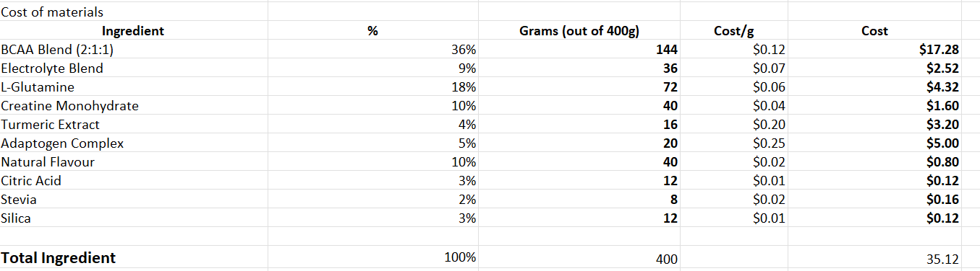
Jelly Sticks/250g Pack
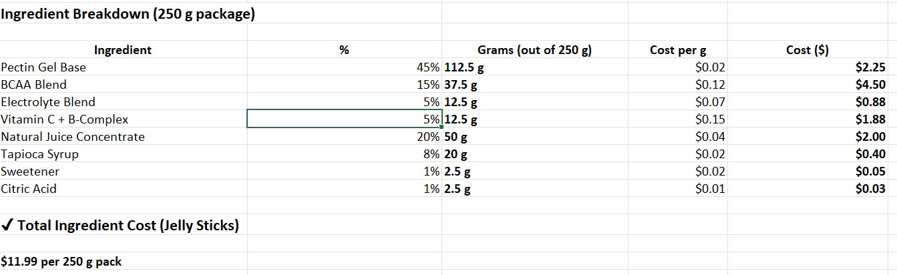
Recharge Pouches/Pouch
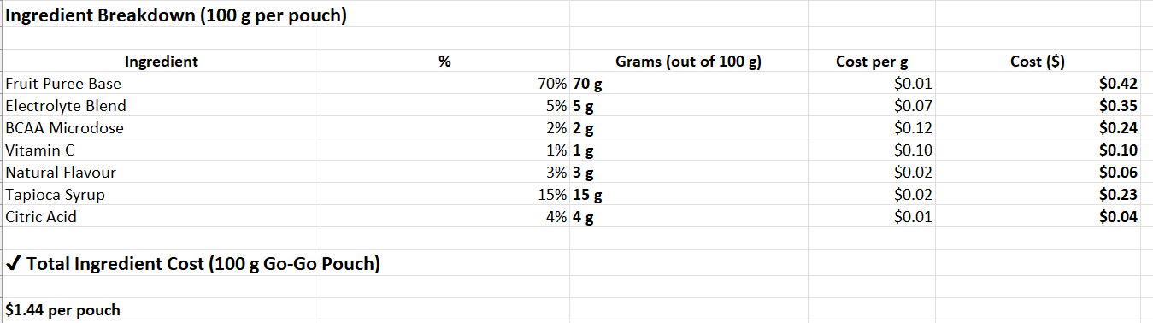
Below is a detailed breakdown of each products packaging costs per unit
Hydration Mix
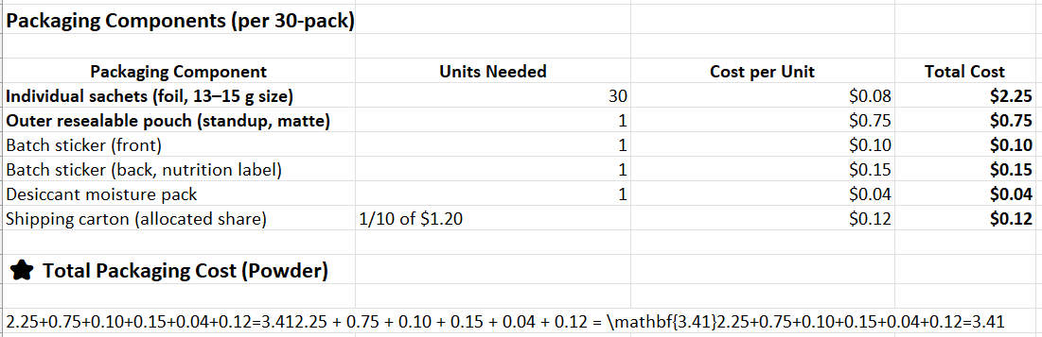
Jelly Sticks
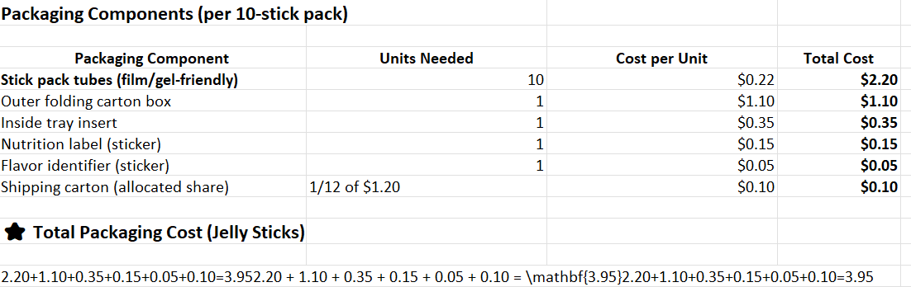

Recovery Pouches
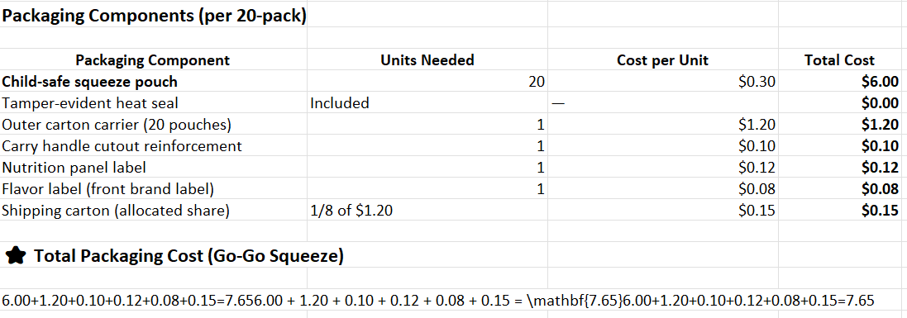
Below is a detailed breakdown of our business’ startup costs:
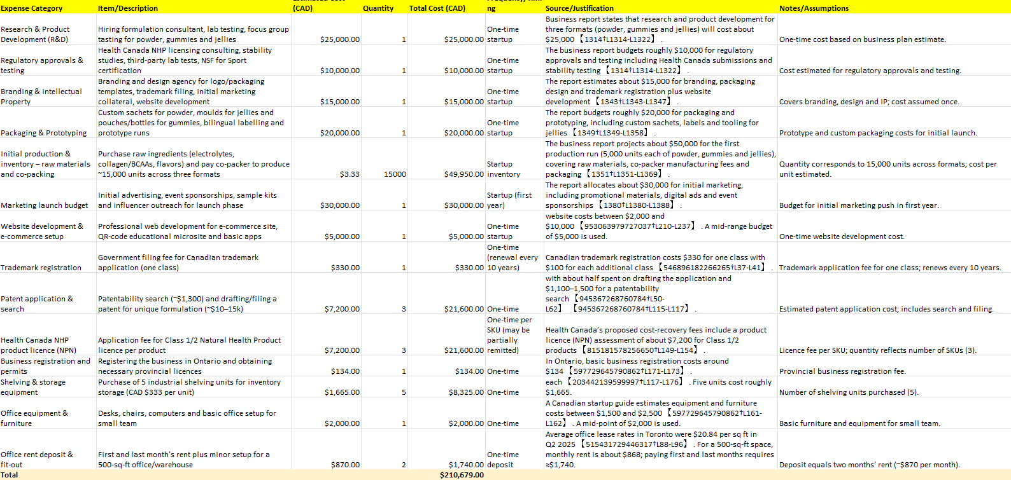

Below is a detailed breakdown of our business’ operating costs:
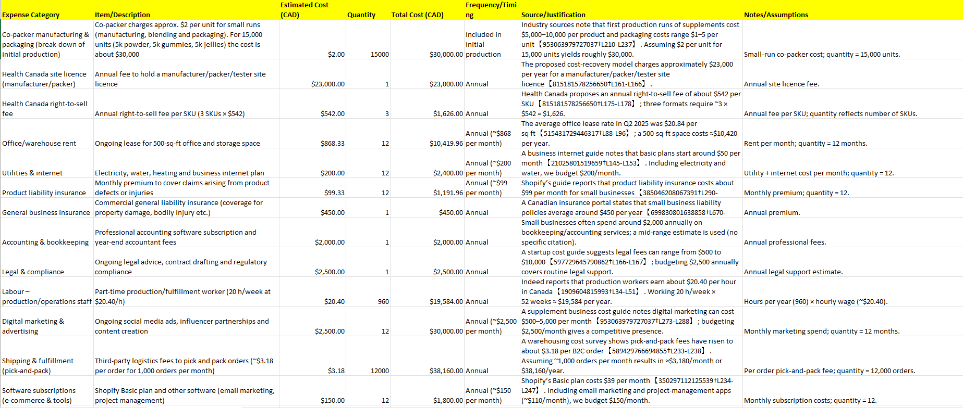
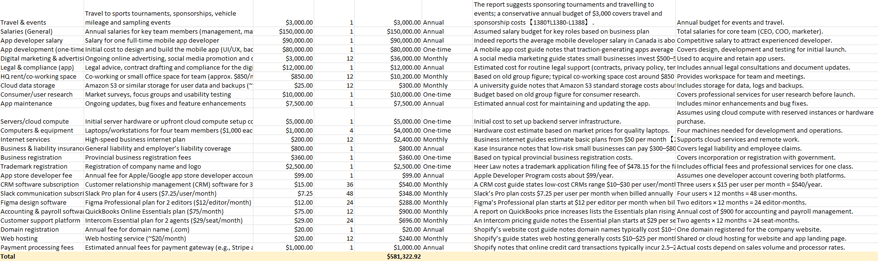
KinetIQ Startup & Operating Expenses
Funding Requirements: We anticipate needing around $300,000 CAD in total funding to reach break-even. This amount would cover the above startup costs plus sustain operations (covering operating expenses and ongoing inventory replenishment) for the first ~18 months until cash flow from sales can support the business.
Our plan is to pursue an angel investment round to secure this $300K. In return, we expect to offer equity in the range of 15% (depending on valuation negotiations). We believe this is reasonable given our early stage and the market potential. The funds will not only launch the product but also give us runway to refine our marketing, achieve key milestones (like X number of monthly subscribers, Y amount of monthly revenue), and be in a strong position by the end of Year 2 either to seek a larger Series A raise or reach self-sufficiency.
We are also open to supplementing this with non-dilutive funding where possible: for instance, applying to programs like Futurpreneur Canada (which provides loans/mentorship for young entrepreneurs) for a portion of the capital, or any available government grants for innovative food products or youth initiatives. We’ve identified a few small business grants and a startup pitch competition in Ontario that we plan to apply to, which could collectively contribute $20–$30K if won.
Nonetheless, the cornerstone of our funding plan is the angel round. The infusion of $300K will be allocated roughly as: $180K to cover the aforementioned startup costs, and $120K as working capital to cover initial operating deficits (monthly expenses like salaries, rent (if any; we mostly work remotely but may use coworking), fulfillment costs, marketing beyond launch, etc.) until sales ramp up. We project that with this funding, we can achieve break-even by the end of Year 3 (as detailed in the projections below), with potential to accelerate profitability if sales exceed our conservative estimates.

6.3 FINANCIAL SUMMARY AND FUNDING REQUESTED
KinetIQ Sports Nutrition Inc. is seeking $377,000 CAD in total funding to launch operations and sustain the business through its first year of activity. This funding will support both one-time startup expenses and initial operating costs required to bring KinetIQ to market and establish early traction. Detailed cost breakdowns are provided in the Financial Appendices.
The funding structure consists of $25,000 CAD in founder investment, approximately $325,000 CAD in angel equity financing, and an estimated $20,000 CAD in grants and youth entrepreneurship funding. Founder capital demonstrates commitment and reduces investor risk, while angel investment provides the primary capital needed for product development, regulatory compliance, manufacturing, and market entry. Grant funding will be used to offset technology, innovation, and education-related costs.
Startup expenses total approximately $210,679 CAD and include formulation development, regulatory approvals, initial production runs, packaging, co-packer deposits, branding, and e-commerce infrastructure. First-year operating costs are projected at $166,132 CAD, covering manufacturing replenishment, marketing, fulfillment, insurance, software, and controlled founder compensation.
The company’s valuation is based on its differentiated youth-focused business model, first-mover advantage in an underserved market, and conservative financial projections showing break-even by Year 2 and profitability by Year 3. Funding secured through this structure provides sufficient runway for KinetIQ to validate product-market fit, scale sales channels, and establish itself as a leading youth sports recovery brand.

6.4 PROJECTED CASH FLOW STATEMENT
Below are KinetIQ’s projected cash flow statements, which outline the expected timing and magnitude of cash inflows and outflows during the startup and early growth phases. Cash flow planning is critical to the successful launch of KinetIQ, as the business incurs significant upfront costs related to product development, regulatory approval, manufacturing, and marketing before revenues fully stabilize.
The management team has carefully analyzed cash inflows from direct-to-consumer sales, subscriptions, and institutional orders, alongside outflows such as manufacturing, marketing, fulfillment, technology, and operating expenses. These projections are used to ensure sufficient liquidity is maintained throughout the year, to anticipate periods of higher cash usage, and to support informed financial decision-making. Detailed monthly and annual cash flow statements are provided in the Financial Appendices.
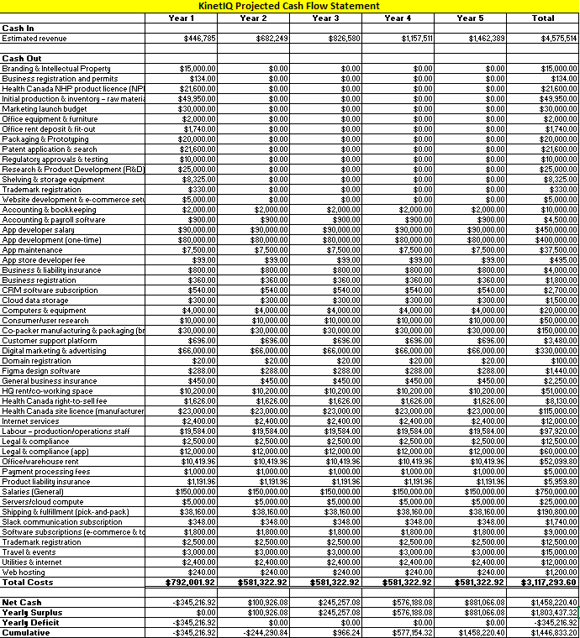
KinetIQ Projected Cash Flow Statement

6.5 PROJECTED INCOME STATEMENT
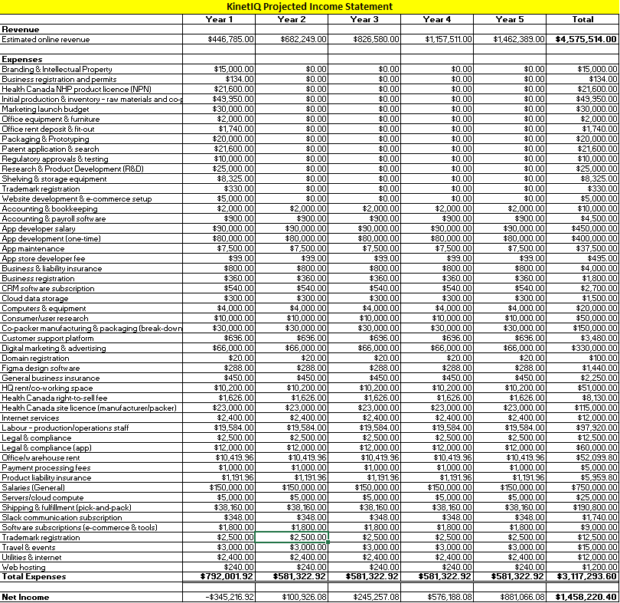KinetIQ Projected Income Statement

6.6 FINANCIAL ASSUMPTIONS

Revenue
KinetIQ’s projected revenue is based on direct-to-consumer sales, subscriptions, and bulk institutional orders to schools, clubs, and sports organizations. Growth projections are supported by primary market research, early interest from athletic programs, and conservative assumptions around customer acquisition and repeat purchases. Revenue is expected to increase steadily as brand awareness grows, subscriptions stabilize cash inflows, and institutional partnerships expand. Detailed revenue projections are reflected in the projected cash flow statements and financial appendices.

Manufacturing and Production Costs
Manufacturing costs include raw ingredients, packaging materials, co-packer labour, quality testing, and setup fees. Because all production is outsourced to certified Canadian co-packers, labour costs associated with mixing, packaging, and quality assurance are embedded within per-unit manufacturing costs. Initial production runs are deliberately conservative to manage inventory risk, with costs decreasing over time as production volumes increase and economies of scale are achieved.

Digital Platform and Website Maintenance
KinetIQ incurs ongoing costs related to maintaining its website, e-commerce platform, and QR-linked Recovery Education system. These costs include platform subscriptions, payment processing, technical support, content updates, and routine maintenance. Rather than employing full-time developers, KinetIQ uses a combination of in-house oversight and outsourced technical services, allowing the company to control costs while maintaining reliable digital functionality.

Marketing and Advertising
Marketing expenses include digital advertising, social media promotions, tournament activations, sampling materials, and branded event equipment. Marketing spend is higher in the early years to support customer acquisition and brand awareness, then becomes more efficient over time as repeat customers, subscriptions, and word-of-mouth referrals increase. These costs are aligned with the marketing strategy outlined earlier in the plan.

Professional Fees and Insurance
Professional expenses include accounting, legal, banking, and advisory services. These costs are incurred on an as-needed basis rather than through salaried positions, keeping fixed costs low. Insurance expenses cover general liability, product liability, and business insurance to protect the company, customers, and partners.

Operating and Administrative Costs
Operating costs include software subscriptions, office technology, fulfillment and shipping coordination, regulatory fees, and business registration expenses. These costs are monitored closely to maintain liquidity and ensure that cash outflows remain aligned with projected revenue growth.

Cash Flow Management
The projected cash flow statements reflect careful timing of cash inflows and outflows to ensure the business maintains sufficient liquidity throughout the year. Upfront expenses occur prior to full revenue stabilization, making cash flow planning a critical management priority. These projections allow KinetIQ to anticipate funding needs, manage burn rate, and support informed financial decision-making.

7.0 PROPRIETARY POSITION & LEGAL/REGULATORY COMPLIANCE

7.1 INTELLECTUAL PROPERTY STRATEGY
KinetIQ’s intellectual property strategy is focused on protecting our brand and any proprietary know-how in formulation:
- Brand Trademarks: Our name “KinetIQ” (and slogan “Recover Smarter. Play Harder.”) will be trademarked. We will register the brand name and logo in relevant classes (supplements, drinks, nutrition products) in Canada (and key future markets) to prevent imitators from using similar names. Establishing trademark protection early safeguards the goodwill we build under our unique brand identity.
- Product Formulations: The specific blend of ingredients in our products – while composed of known nutritional elements – is a competitive differentiator. Although the formula itself may not be easily patentable (since it primarily uses known ingredients in novel combination), we will protect it as a trade secret. Our contract manufacturing agreements will include confidentiality clauses to ensure the formulas are not shared. If we do innovate on processing or delivery methods (for instance, a unique way to encapsulate an ingredient for better absorption in kids), we will explore patent protection for those specific process innovations.
- Educational Content: The recovery education content (videos, materials) we create is another asset. We’ll retain copyright on all our original content. This content differentiates our product experience, and while we want it widely viewed (even by non-customers, as marketing), we will brand it clearly so it always ties back to KinetIQ.
Overall, our IP approach is about building a moat around the brand itself and the trust it carries. Even if competitors replicate a similar formula down the line, a strong protected brand identity and loyal community will keep KinetIQ ahead.

7.2 REGULATORY REQUIREMENTS (HEALTH CANADA)
Compliance with health and safety regulations is non-negotiable for KinetIQ. In Canada, supplements fall under regulations for Natural Health Products (NHPs) as governed by Health Canada:
- Product Licensing (NHP Numbers): Each of our products will be submitted for review to get an NHP license, which provides a registration number indicating Health Canada has reviewed its safety and claims. We are prepared to provide all required documentation on ingredients, doses, and supporting scientific rationale to expedite approval. Our formulations are designed with well-known ingredients at safe levels for youth, so we anticipate a smooth licensing process.
- Labeling and Claims: We will ensure our packaging and marketing claims adhere strictly to regulations. This means using acceptable wording (e.g. “helps in muscle tissue formation” rather than an unapproved term like “builds muscle faster”) and including all required cautionary statements. For example, we’ll note that the product is for youth above a certain age, and include allergen warnings, etc., as required. Our labels will also be bilingual (English/French) to meet Canadian requirements.
- Facilities and Quality: Our manufacturing will be done in a facility that holds a site license for NHP manufacturing. This ensures they follow Good Manufacturing Practices (GMP) specific to supplements. We will validate that our manufacturer conducts proper batch testing, record-keeping, and can provide Certificates of Analysis for ingredients and final product. Before distribution, we’ll also do our own spot-testing of product batches via independent labs to double-check compliance (e.g. verify no contaminants, ingredient potency matches label).
- Import/International Compliance: Although we start in Canada, we have an eye on future international expansion (like the U.S.). We will stay informed on relevant regulations (FDA supplement rules, etc.) and design our quality systems to meet the highest-standard requirements. Early on, we may also pursue NSF Certified for Sport as mentioned, which, aside from quality assurance, helps compliance by ensuring no banned substances.
By proactively integrating regulatory compliance into our operations from day one, we minimize the risk of any legal issues or delays. This not only keeps us on the right side of the law but also builds trust with consumers (parents will know we take safety seriously).

7.3 QUALITY ASSURANCE & CERTIFICATIONS
Quality assurance is critical given our target market’s vulnerability (children) and the trust we must earn from parents and coaches. Our QA strategy includes:
- Third-Party Testing & Certifications: We plan to have an independent lab test our products for purity and label accuracy. Additionally, we will seek NSF Certified for Sport certification for our flagship products. This certification involves rigorous testing to ensure the product is free from banned substances and contaminants, and that what’s on the label is in the product. Achieving this gives a strong assurance to consumers (and sports organizations) of our quality.
- Ingredient Sourcing Standards: We source only from reputable suppliers who provide high-grade, tested ingredients (e.g. electrolyte minerals, amino acids, vitamins). Whenever possible, we use pharmacopeia-grade or certified organic components. We avoid any ingredients with known safety questions for youth. Each ingredient lot will come with a Certificate of Analysis, and we’ll do random verification tests.
- Manufacturing Audits: Even though we outsource production, we will conduct periodic audits of the manufacturing facility (or review their audit reports). We want to ensure they maintain GMPs, proper sanitation, allergen controls (important if we promise allergen-free products), and consistent mixing and packaging processes so every sachet/stick/gummy is uniform in content.
- Continuous Improvement: We will implement a feedback loop from customer experience to quality control. For instance, if we receive any complaint (taste, effect, packaging issue), it will be logged and investigated. Maybe a batch needs a formula tweak or a packaging supplier’s quality slipped – we will trace issues and address root causes swiftly. Given we are a small company, this agility in improving quality will be a competitive advantage.
- Expiration and Stability: We’ll perform accelerated stability testing on our products to validate their shelf life. Our goal is to have at least an 18-24 month shelf life on all formats. We’ll print clear expiry dates and storage instructions on packaging. During distribution, we’ll use lot codes to track products, which also allows recall management if ever needed (though we aim never to need it, it’s important to have the system in place).
By adhering to these stringent QA practices and obtaining respected certifications, we strengthen our market position as a premium, trustworthy brand. Parents can have confidence that KinetIQ’s products are not only effective but also produced to the highest safety and quality standards.

8.0 SOCIAL IMPACT STRATEGY
KinetIQ isn’t just about business – it’s built on a vision of positive social impact in youth sports culture. We believe in nurturing not only the bodies of young athletes, but also their communities and environment. Our social impact strategy has three pillars:

8.1 COMMUNITY ENGAGEMENT & “KINETIQ FOR ALL” INITIATIVE
From day one, we intend to give back to the community that supports us. Our “KinetIQ for All” initiative is a program where we allocate a portion of product or profits to help underprivileged youth athletes. As the company grows, we will partner with local youth sports programs in low-income or under-funded areas, donating KinetIQ products (or equivalent funds) so that kids who might not afford recovery supplements can still benefit from them. For example, we might supply a whole season’s worth of KinetIQ hydration mix to a community football league that lacks resources, or sponsor an after-school sports program with both products and educational workshops. The goal is to ensure all young athletes, regardless of background, have the resources to play and recover safely.
Additionally, community engagement means actively participating beyond donations. We will volunteer and encourage our employees to volunteer at sports clinics, school events, or local Boys & Girls Clubs to promote healthy habits. By being physically present and involved, KinetIQ positions itself as a caring member of the youth sports community. This not only builds goodwill but aligns with our mission – we’re here to revive youth sports culture, especially where it’s most needed.

8.2 DIVERSITY, EQUITY & INCLUSION (DEI)
Our social impact strategy also encompasses creating an equitable and inclusive brand. We are committed to diversity and inclusion in both our workforce and our marketing. As we grow our team, we will strive for a staff that reflects the diverse communities we serve. Internally, that means equal opportunity hiring and fostering an inclusive culture where different perspectives are valued.
In terms of marketing and partnerships, we will ensure our campaigns feature a diverse range of athletes (boys and girls of different backgrounds, abilities, and ethnicities) so that any kid can see KinetIQ and feel “this is for me.” We will reach out to communities that are often underrepresented in youth sports promotion – for instance, collaborating with initiatives that encourage girls in sports, or programs for Indigenous youth athletics. When sponsoring or donating, we’ll include a mix of sports beyond the traditional high-profile ones, recognizing that diversity also means supporting different interests (from soccer to badminton to dance).
By weaving DEI into our operations, we hope to empower all young athletes. Every kid, no matter who they are or where they come from, should feel included in the KinetIQ movement and confident that they belong in the world of sports and wellness.

8.3 ENVIRONMENTAL RESPONSIBILITY
While social impact on people is our primary focus, we also take environmental responsibility seriously. We recognize that how we package and produce our product can have an impact on the planet that these young athletes will inherit.
Our first step is sustainable packaging. We use recyclable materials for our boxes and pouches whenever feasible (e.g. cardboard boxes for jelly sticks that are recyclable). We are also actively exploring innovative packaging, such as compostable film sachets or biodegradable wrappers for the sticks and gummies. If a fully compostable solution isn’t immediately viable due to product freshness concerns, we will at least transition to packaging made from recycled content or that uses less plastic overall.
We also minimize waste in production by working closely with our manufacturer on efficient batch sizes to avoid overproduction. Any surplus or near-expiry product that is still safe will, whenever possible, be donated rather than thrown out (tying into our community aspect but also preventing waste).
For shipping, we opt for minimal packaging – the shipping materials will be right-sized and recyclable. As we scale, we’ll look into carbon offset programs for our logistics or choose fulfillment partners with carbon-neutral shipping options to reduce our footprint.
Finally, we incorporate environmental consciousness into our brand messaging: part of educating youth is also encouraging them to respect the environment. Small touches like including a reminder on our packs to recycle, or content about the importance of caring for their “playing field” (earth) can instill those values. By doing business responsibly, we aim to build a brand that young athletes and their parents feel proud supporting, knowing that we care for the environment that sustains us all.

9.0 BRANDING AND PRICING STRATEGY

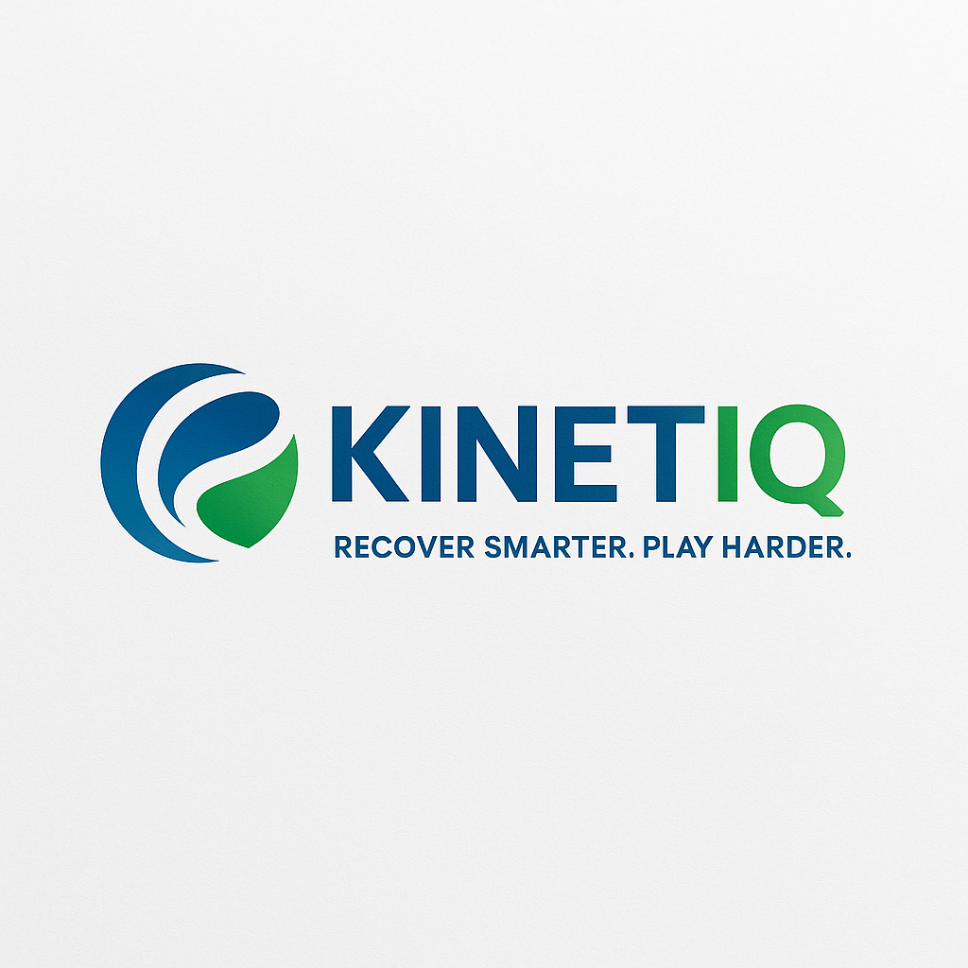

9.1 BRAND IDENTITY AND POSITIONING
Our brand identity is all about being youthful, empowering, and trustworthy. “KinetIQ” as a name means “to give new energy or vigor,” capturing exactly what we aim to do for young athletes. The branding carries a vibrant, energetic aesthetic: our logo and packaging use bright, sporty colors (greens, blues, oranges) that appeal to kids and stand out on a shelf or in a gym bag. The design features dynamic shapes (suggestive of motion) and playful but modern fonts.
We position KinetIQ as the ally for youth athletes. The tone in our messaging is like a friendly coach or mentor – encouraging and positive (“Play harder, recover smarter!”) – rather than clinical or overly technical. At the same time, we emphasize that we are science-backed and parent-approved. For example, our tagline “Recover Smarter. Play Harder.” encapsulates the idea that using our product helps you be a smarter athlete and have more fun playing.
On packaging and marketing materials, we balance the appeal: there are fun icons and possibly a mascot or graphic element that kids find cool (like a lightning bolt character symbolizing energy), alongside trust markers for parents (like “No Sugar Added,” “NSF Certified,” etc., clearly displayed). We also highlight our educational link (e.g., a blurb: “Scan the code to get recovery tips!” on the box) to reinforce that we’re more than just a supplement – we’re a partner in their athletic journey.
Our brand voice is encouraging, knowledgeable, and inclusive. We avoid talking down to kids; instead, we engage them. For parents, we communicate with clarity and honesty – we present facts (like why each ingredient is included) in an approachable way. We want to become known as the brand that genuinely cares about young athletes’ well-being and skill development, not just selling a product. This mission-driven aspect (our social impact efforts, our educational content) is front and center in brand storytelling.
By cultivating this identity, KinetIQ will occupy a unique space in consumers’ minds: when they think “youth sports nutrition” or “after-game recovery for my kid,” our brand should be the first and trusted choice.

9.2 PRICING STRATEGY
Our pricing is set at a premium-yet-accessible level. We position KinetIQ as a high-quality product (with clean ingredients, multiple benefits in one) worth a bit more, but we also recognize parents must justify the cost within a family budget. We’ve priced each format such that per serving, it’s in the range of what someone might pay for a typical sports drink or a protein snack, with a slight premium for the added benefits.
For example:
- The Hydration Powder pouch (30 servings) is priced around $19.99–$21.99 (CAD) retail. This works out to roughly $0.70 per serving. We intentionally kept the cost per drink well under $1 to encourage daily use and compete with bottled sports drinks on value (a 500mL sports drink often costs $1–$2).
- The Jelly Sticks box (10 sticks) might be $14.99 (so about $1.50 per stick/serving). This is comparable to buying a premium organic snack but with much more functionality.
- The Gummies (let’s say 20 gummies = 10 servings per bottle) might also be about $14.99–$16.99 per bottle, roughly $1.50–$1.70 per serving.
From these, a parent making a one-time purchase might spend $35–$40 for a month’s supply of a couple formats, which is a commitment but within reach for our target demographic (health-conscious families already spending on sports and nutrition).
We also will offer bundle pricing – e.g., a “Starter Pack” with one of each format at a slight discount, to encourage trial of all products. And subscription pricing will be about 10% less than one-off (providing an incentive to subscribe, which is good for retention and our revenue predictability).
It’s worth noting that our premium pricing is justified by our value proposition: we often communicate to parents that for about $1.50 a day, you are safeguarding your child’s health and maximizing their performance – a worthy investment. We back this by highlighting quality (e.g., no cheap fillers, we use real fruit, etc.) and efficiency (you’d otherwise have to buy separate drinks, protein bars, vitamins to get what KinetIQ provides in one).
In terms of market comparison, a tub of adult protein powder can be $40–$50 (but many parents are hesitant to buy that for a kid), and a 12-pack of sports drinks is about $10–$12 (but full of sugar). So we are somewhat in the middle ground – more expensive than Gatorade, but far more tailored and beneficial; cheaper than piecemeal supplements and certainly cheaper than any potential medical costs of poor recovery. That’s the narrative we subtly push.
We will monitor price feedback closely. If we encounter resistance (“it’s too expensive”), we have some flexibility – thanks to healthy margins – to run promotions or adjust packaging size. For instance, we could introduce a smaller pouch of powder (15 servings for $11.99) as a lower entry point in retail. But our research indicates our target segment is willing to pay a bit more for something they perceive as genuinely healthier for their kids, especially if it lasts a month.
Finally, we maintain a consistent pricing policy across channels initially (our website and any direct partnerships) to avoid undercutting ourselves. If/when we enter retail, we’ll ensure MRSP allows for retailer margins without breaking the “affordable premium” image. We’d rather slightly reduce our margin for a big retailer order than have them jack up the shelf price beyond what is acceptable to parents.
In summary, our pricing strategy aims to reflect KinetIQ’s quality and comprehensive benefits while still being seen as a reasonable regular expense for families with young athletes. We believe this balance will maximize both our market penetration and our profitability.

10.0 Appendix

A. INGREDIENT COMPOSITION PER PRODUCT FORMAT
To provide transparency and detail, below are highlights of the ingredient breakdowns for each KinetIQ product format, along with typical per-serving quantities and roles:
- Hydration Powder (per 1 sachet ~13 g): Approx. 35–40% BCAA blend (around 5 g BCAAs per serving, 2:1:1 ratio of leucine:iso-leucine:valine) plus ~2.5 g L-Glutamine, ~1.3 g creatine monohydrate, an electrolyte mix (~300 mg sodium, 80 mg potassium, 20 mg magnesium), vitamin C (~100 mg) and B-vitamins, and a natural anti-inflammatory extract (~100 mg turmeric). Role: Rapid rehydration and muscle recovery in one, with no sugar (sweetened by stevia/monk fruit).
- Jelly Sticks (per 1 stick ~25 g): Primarily a water and fruit-based gel delivering hydration and carbs: ~100 mg natural sodium (from sea salt or electrolyte mix) and 50 mg potassium, ~2 g added BCAAs, plus vitamin C (~50 mg) and B-complex vitamins from fruit juice concentrates. Contains a small amount of turmeric or tart cherry equivalent to ~50 mg active, for anti-inflammatory effect. Natural fruit sugars (~2 g) provide quick energy but keep total sugar low. Role: Convenient post-activity snack that replenishes some electrolytes and vitamins while offering light protein building blocks.
- Chewable Gummies (per ~2-3 gummies serving ~20 g): A gelatin/pectin gummy base with added collagen peptides or BCAAs (~2 g per serving) for muscle and joint support. Includes electrolytes (~100 mg sodium, 50 mg potassium) in the gummy matrix, plus vitamins D (~200 IU) and calcium (~50 mg) to support bones (since many youths have vitamin D insufficiency). Uses natural colors/flavors, with ~1–2 g of sugar (from tapioca or cane syrup) just for structure. Role: Fun, candy-like delivery of recovery nutrients, emphasizing muscle/bone support to complement the hydration from other formats.
(Full detailed ingredient tables with all components and percentages are available in our internal documentation and can be provided to interested parties. All ingredients are compliant with Health Canada’s approved NHP ingredient list.)

B. MANUFACTURING AND PACKAGING COST BREAKDOWN PER PRODUCT
We have estimated the per-unit manufacturing and packaging costs to ensure our pricing yields healthy margins. Below is a summary of the packaging components and costs for each format (approximate):
- Hydration Powder: Each retail pouch contains 30 sachets. Packaging includes 30 foil sachets (about $0.075 each, ~$2.25 for all) plus an outer resealable pouch (about $0.75 each). Total packaging cost per pouch is roughly $3.00. Manufacturing (mixing & filling) cost for powder ingredients per pouch is about $4.00. So COGS for one pouch is ~$7.00. At a retail price of ~$20, this format has a solid margin. Per serving, packaging cost is only ~$0.10, ingredient cost ~$0.13, total ~$0.23 per serving COGS.
- Jelly Sticks: 10 sticks per box. Each stick pack (film wrapper) is about $0.10, so $1.00 for 10. The carton box is another ~$0.40. Filling the jelly (which requires specialized equipment for the puree) costs about $0.80 for all 10 (ingredients for the gel are a bit more costly than powder per serving due to fruit concentrates). Total COGS for a box of jellies is around $2.20–$2.50. With a retail of ~$15, we maintain a margin, though slightly lower than powder due to higher packaging cost per serving (~$0.15 each stick).
- Gummies: ~10 servings (20-30 gummies) per bottle. The bottle plus cap is about $0.50, and there’s a small desiccant inside ~$0.05. Gummy manufacturing (cooking, molding) for a bottle is about $1.00 in ingredient and labor cost (gelatin/pectin, actives, etc.). Total COGS per bottle ~$1.55. Retailing at ~$15 as well, margin is strong. Packaging per serving of gummies is very low (~$0.04) since one bottle covers multiple servings.
Economies of scale: these costs will drop slightly (~10-15%) at higher production volumes (our manufacturer gave us price breaks at larger batch thresholds). We’ve built initial margins assuming current small scale costs, so any improvement will be upside.
We will continuously monitor COGS and seek cost optimizations (for instance, sourcing some ingredients in bulk globally if cheaper, or tweaking packaging if we find a more cost-effective eco-friendly material). Our goal is to keep gross margins ~60% or above on direct sales, which these estimates achieve.
(Detailed cost tables and quotes from suppliers are available in our financial appendix. Figures above are rounded for clarity.)

C. PRODUCT VISUALS & DIAGRAMS
Below we include conceptual visuals and diagrams related to KinetIQ’s product and branding (for reference in presentations or further design work):
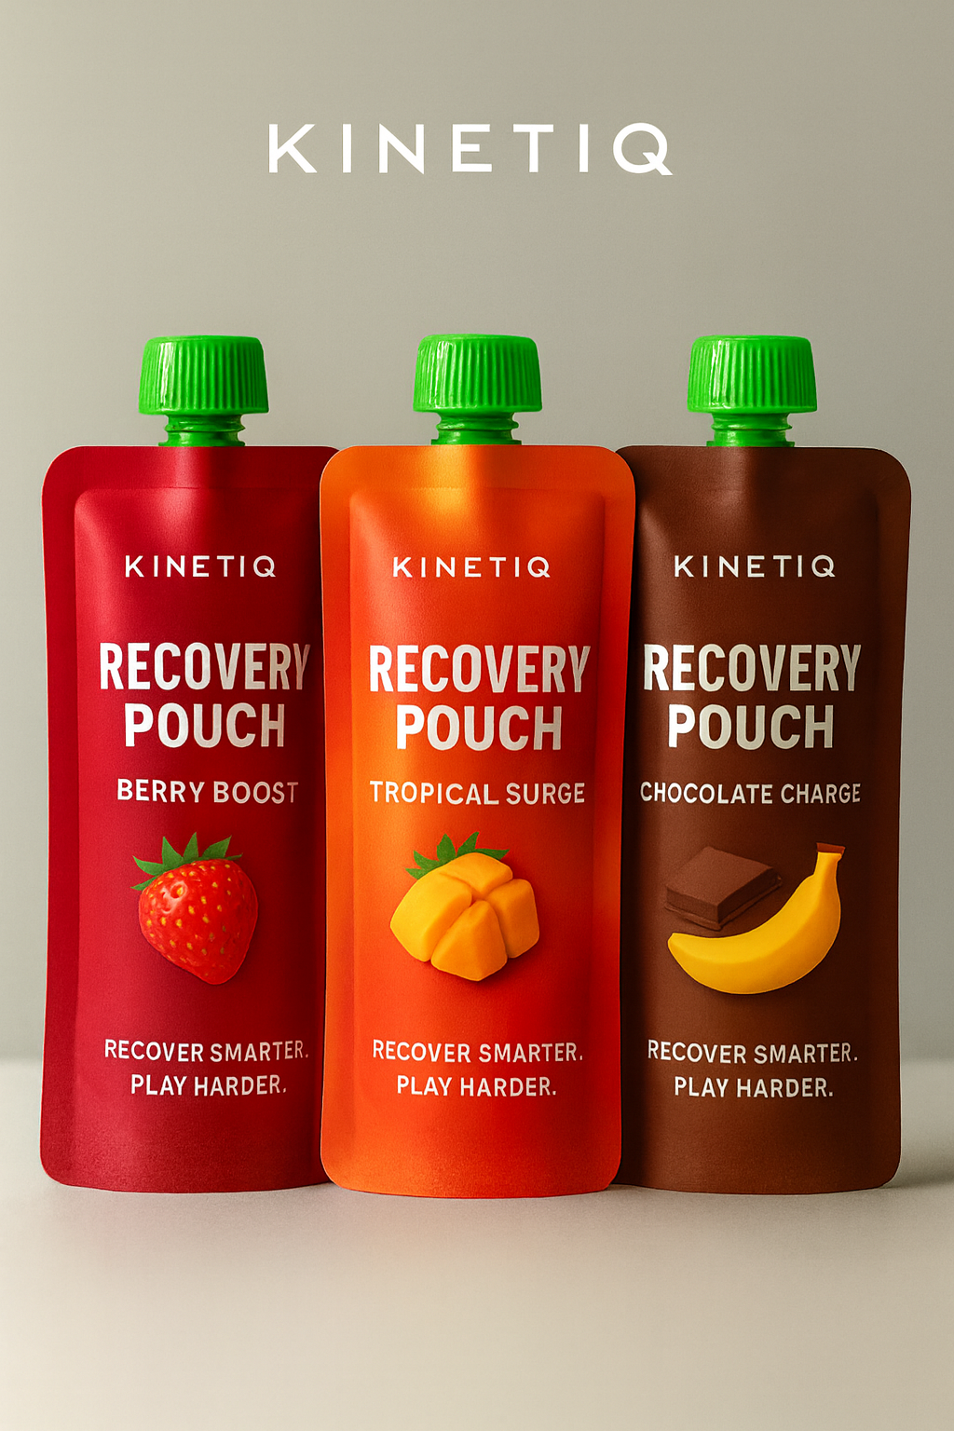
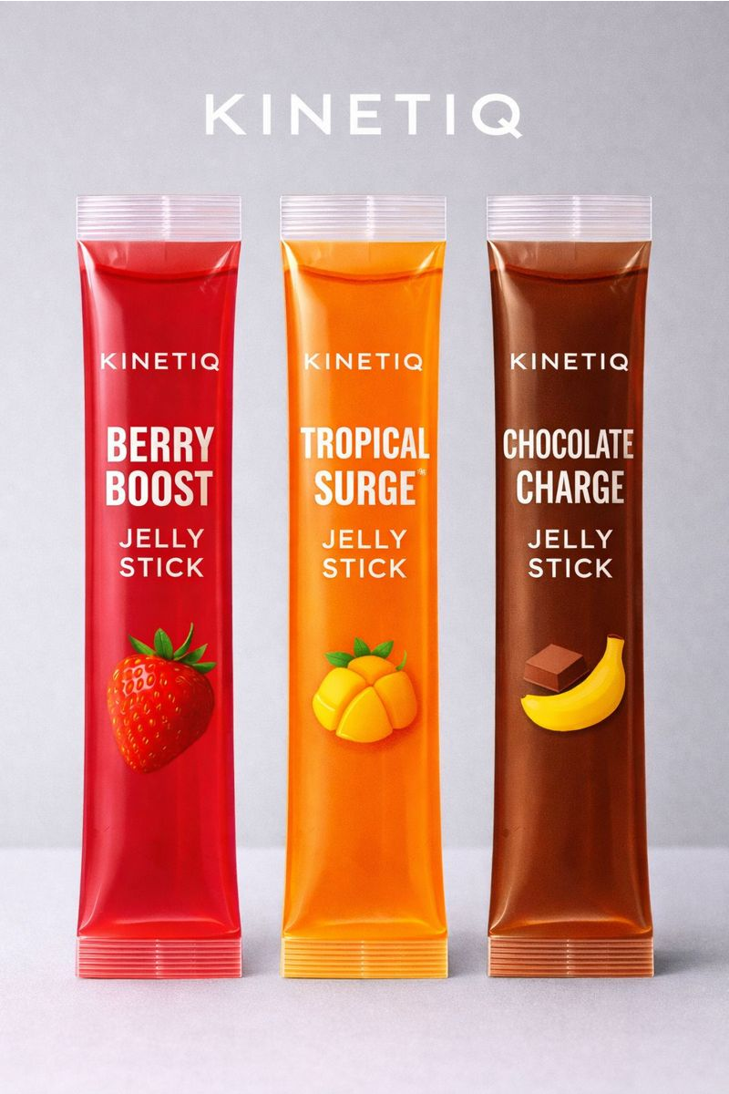
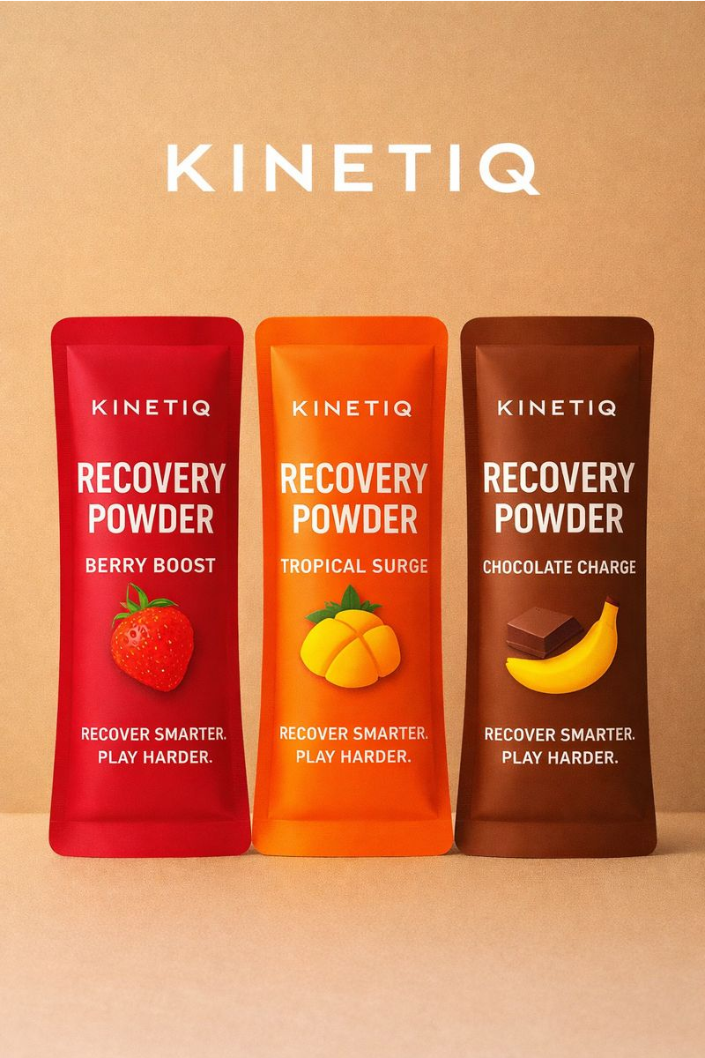
- Packaging Mockups: We have high-resolution mockup images of each product’s packaging. These show the front-of-package design (with the KinetIQ logo, product name, key benefit callouts like “3-in-1 Recovery for Kids”, and a vibrant color scheme). The images illustrate the size and appearance of the powder pouch, jelly stick box, and gummy bottle, giving a sense of how they will look on a shelf or in a gym bag. (See attached Figure C1, C2, C3 for each format’s package design.)

- Usage Diagrams: To educate customers, we use clear, kid-friendly infographics that visually explain how and when to use KinetIQ products. One diagram, titled “How KinetIQ Works,” shows a young athlete and highlights our 3-in-1 recovery system: hydration (electrolytes and fluids replenishing the body), muscle repair (nutrients supporting muscle recovery), and inflammation control (supporting overall recovery and comfort). A second diagram illustrates the Recovery Routine, presented as a simple step-by-step timeline: immediately after activity, athletes refuel with KinetIQ products (hydration mix, jelly sticks, or recovery pouches), followed by light stretching and rest, leading to improved recovery and readiness to perform the next day. Together, these visuals provide a quick, engaging overview that helps young athletes and parents understand the purpose and proper use of KinetIQ products (See below for the Recovery Routine graphic.)
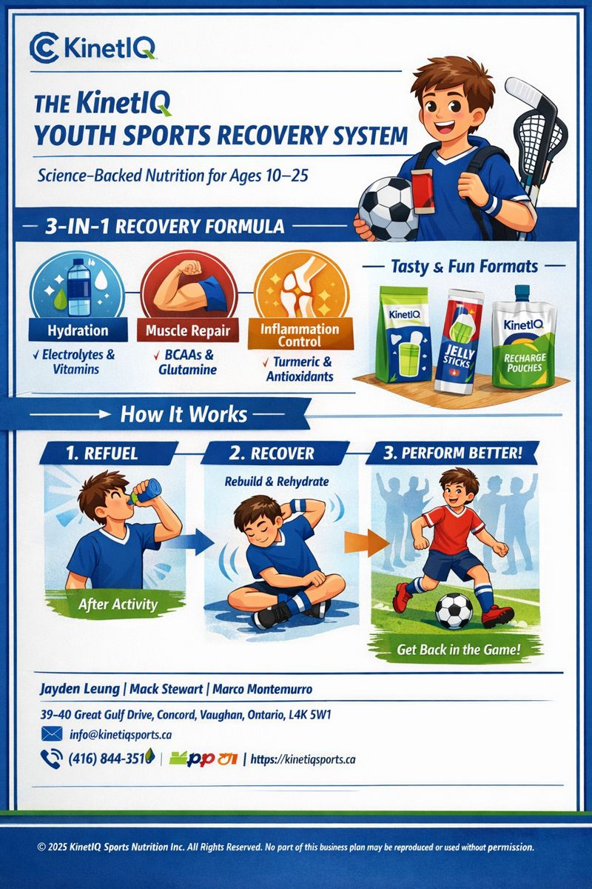
- Brand Logo & Slogan: The KinetIQ logo represents the connection between movement, recovery, and intelligence. The flowing blue and green symbol reflects continuous motion and renewal; blue standing for hydration, science, and trust, and green representing health, growth, and smart decision-making. The name KinetIQ comes from kinetics (movement) and IQ (intelligence), highlighting our belief that athletic recovery should be science-backed and intentional. Together, the logo and name reinforce our mission to help athletes recover smarter so they can play harder.
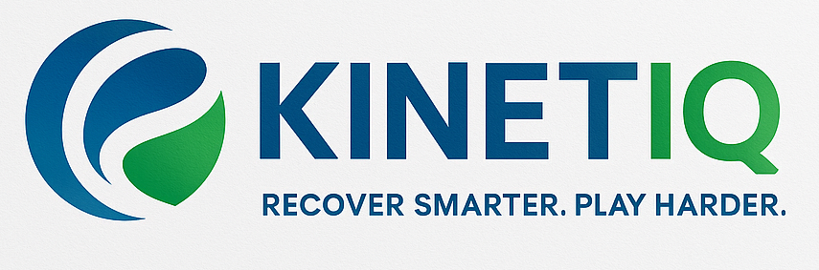

D. FINANCIAL DATA AND CHARTS
This section provides supporting financial details from our projections and cost analysis:
D1. Multi-Year Financial Projections (Summary Table):
A table summarizing Year 1, 2, 3 projections for units sold by product, revenue, gross margin, expense categories, and net income. For example, it lists how many powder pouches, jelly boxes, and gummy bottles we expect to sell each year, the revenue from each, and the assumptions on growth. It also breaks down expenses into marketing, personnel, operations, etc. Key insight: by Year 3, subscription sales form ~40% of total sales, improving revenue stability. (Refer to Figures in 6.2, 6.3, 6.4 for the table and a breakeven chart plotting cumulative cash flow turning positive just before Year 4.)
D2. Unit Economics Analysis:
A breakdown showing the contribution margin per unit of each product. For instance, for one powder pouch: sale price $20, COGS $7 (as detailed in Appendix B), fulfillment $1, resulting contribution $12 per pouch. Similar breakdown for jellies and gummies. This section illustrates that even after accounting for an average $2 per order in shipping subsidies or transaction fees, each sale contributes healthy gross profit that can cover marketing and other overhead. (Figure D2 is a bar chart comparing margin per unit across products.)
D3. Marketing ROI Calculation:
Data showing how our customer acquisition cost (CAC) compares to lifetime value (LTV). We project an average CAC in Year 1 of about $15 (through a mix of events and digital ads), dropping to $10 by Year 3 as word-of-mouth grows. Meanwhile, the projected LTV of a customer is around $120 (assuming they stay ~1.5 years and spend $80/year). This 8:1 LTV:CAC ratio is very strong and underpins our investment in marketing. (Figure D3 provides a line graph of CAC declining and cumulative LTV of cohorts over time.)

D4. Cash Flow Projection Detail:
A month-by-month cash flow for the first 18 months, showing the timing of cash needs. For instance, it highlights that our big cash outflows for inventory happen in Month -2 (pre-launch production) and Month 6 (second production run), and how the influx of the angel investment covers those. We maintain a minimum cash buffer of ~$50K at the lowest point. This detail helps in planning the financing drawdown and ensures we don’t encounter a crunch. (No figure, but the spreadsheet excerpt is available upon request.)
All charts and tables reinforce that our financial plan is viable and that KinetIQ can achieve sustainability with the proposed funding. The data also helps identify key sensitivities (e.g., if sales are 20% lower, we see from the model we’d burn cash a few months longer — which is manageable with slight expense cuts).
(Note: Detailed spreadsheets and calculations are available in the full financial model document for investors who wish to delve deeper. The charts here are for illustration and quick reference.)

Ingredients:
Youth/Team (No-Creatine) — 15 g sachet

Has single-compound actives + systems:

L-Glutamine: C5H10N2O3

L-Leucine: C₆H₁₃NO₂

Sodium chloride (table salt): NaCl

Sodium citrate (trisodium citrate, anhydrous): Na₃C₆H₅O₇

(common hydrate: Na₃C₆H₅O₇·2H₂O)

Potassium citrate (tripotassium citrate): K₃C₆H₅O₇

Magnesium citrate (tribasic, anhydrous core): Mg₃(C₆H₅O₇)₂ (often sold as hydrates; exact n in ·nH₂O varies)

Vitamin C (ascorbic acid): C₆H₈O₆

Curcumin (from turmeric): C₂₁H₂₀O₆

Citric acid (acidulant): C₆H₈O₇

Malic acid (acidulant): C₄H₆O₅

Silica (anti-caking): SiO₂

Tricalcium phosphate (anti-caking, optional): Ca₃(PO₄)₂

Stevia glycosides (sweetener, e.g., Rebaudioside A): C₄₄H₇₀O₂₃

(another common one, Stevioside: C₃₈H₆₀O₁₈)

Monk fruit glycoside (Mogroside V, if used): C₆₀H₁₀₂O₂₉

Mixtures (no single formula):

Whey protein isolate or pea protein isolate — mixture of proteins (polypeptides)

Tart cherry extract — mixture (anthocyanins, polyphenols)

Natural flavors / fruit powders — mixtures

Maltodextrin (carrier) — polymer mixture, idealized repeat unit (C₆H₁₀O₅)ₙ

Pro (Creatine) — 20 g sachet

All of the above, plus:

Creatine monohydrate: C₄H₉N₃O₂·H₂O

(anhydrous creatine base: C₄H₉N₃O₂)

(Electrolytes, acids, vitamins, sweeteners, and processing aids share the same formulas as listed in Youth/Team.)

E. ARCGIS BUSINESS ANALYST CONSUMER DEMOGRAPHIC PROFILING
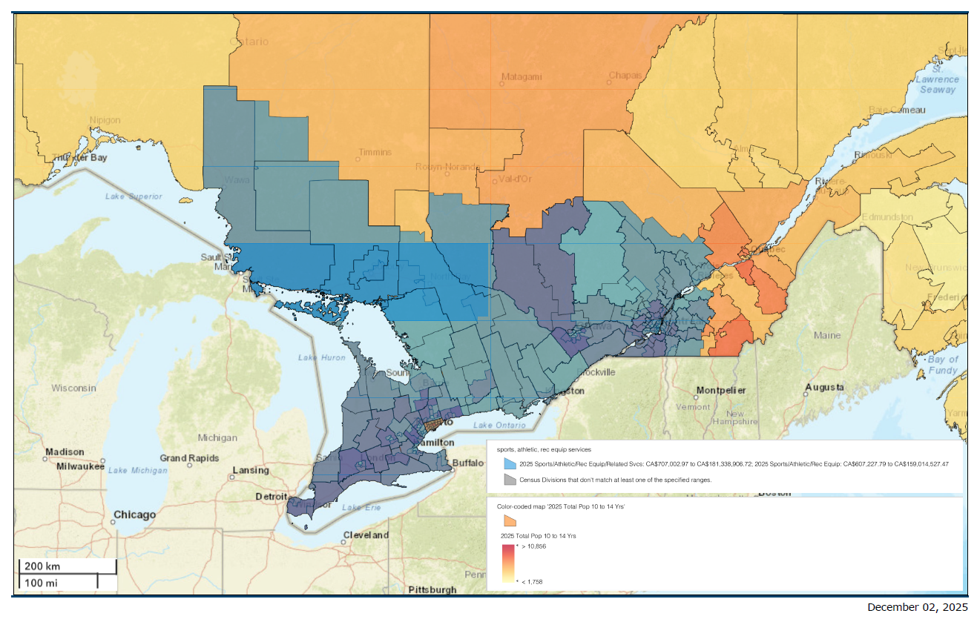
Figure 1: Color-Coded Map of 2025 Total Population Ages 10–14 in Ontario Using Sports, Athletic & Rec Equip Services
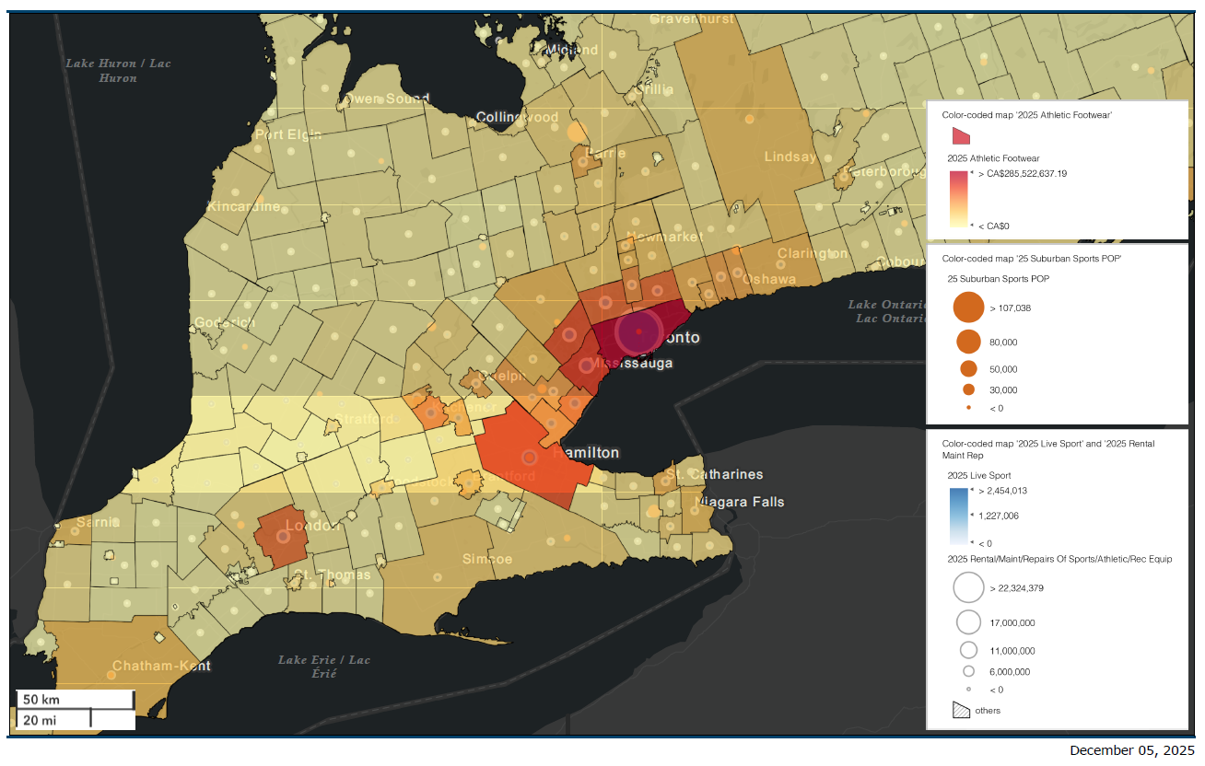
Figure 2: Market Density and Sports/Athletic Spending Indicators Across Southern Ontario (2025)

F. FULL RÉSUMÉ OF BUSINSESS LEADERS
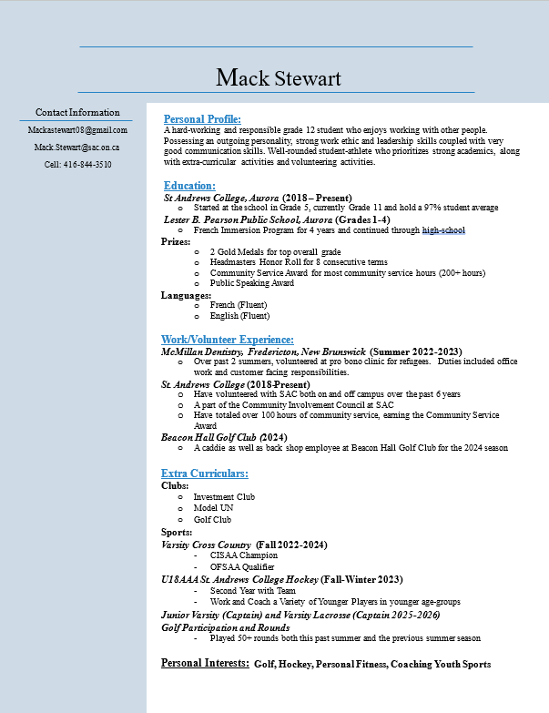
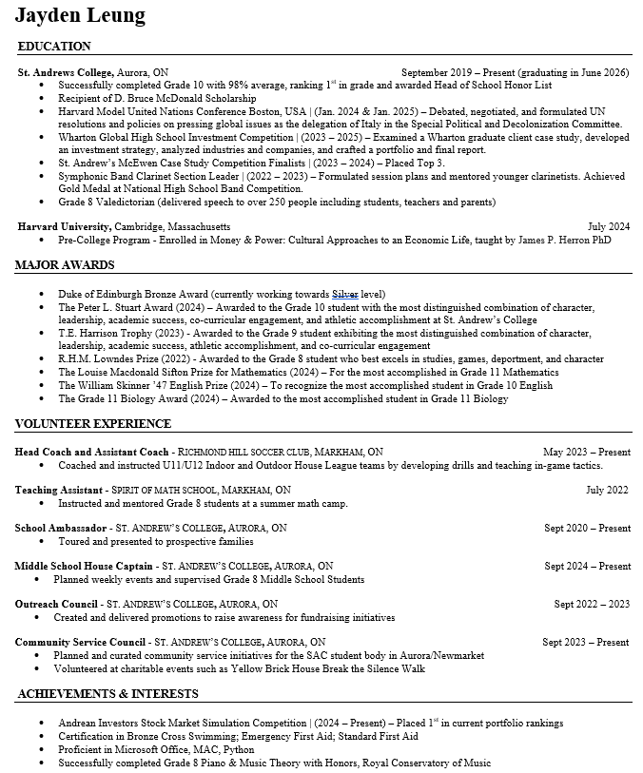

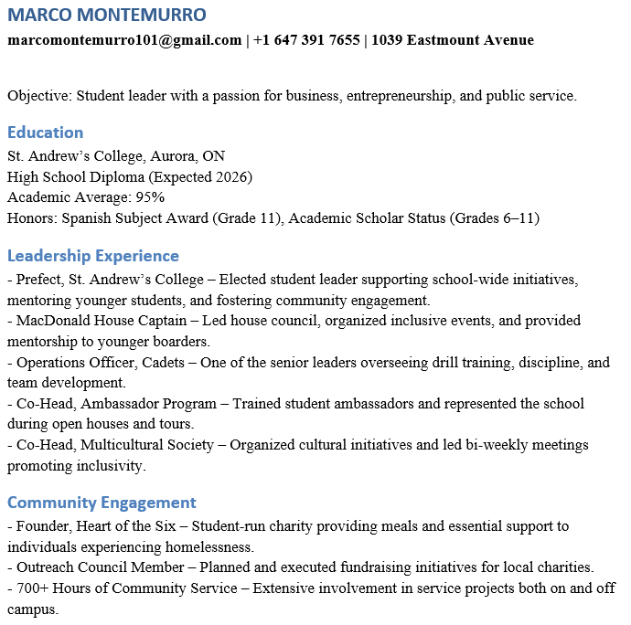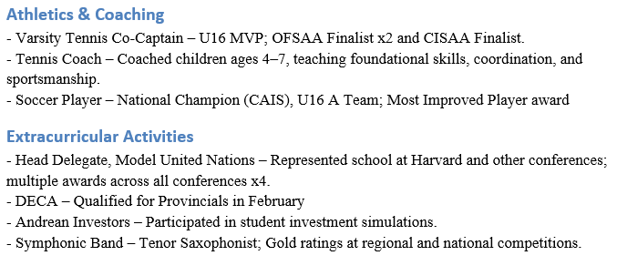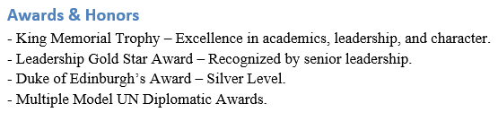

G. ACKNOWLEDGEMENTS
KinetIQ would like to thank Mr. Sean Ludwig, Athletic Therapy, Mr. Joe Morrisey, Mr. Joe Comisso, Mr.
Giancarlo Trimarchi, and Ms. Diane Craig for their contributions, support, and advice throughout
the process of launching our company. Additionally, KinetIQ cannot begin to express its immense
gratitude towards Mr. Robert McEwen for continuing to fund and support the McEwen Business
Program at St. Andrew’s College, which without, this report would not have been possible.

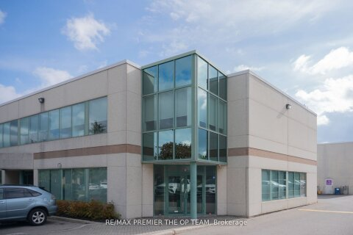
H. KINETIQ OFFICE AND LAYOUT

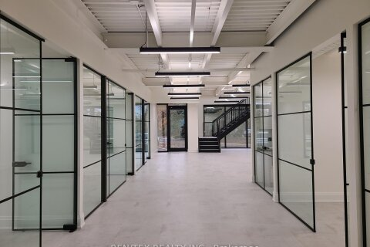


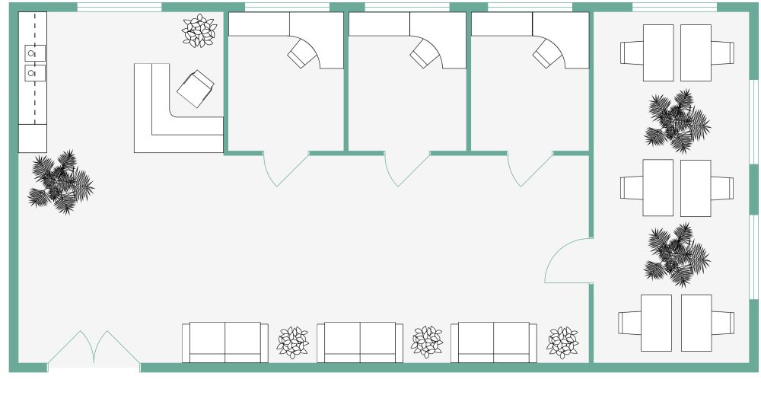

https://store.mintel.com/report/us-private-label-food-and-drink-market-report
https://nielseniq.com/global/en/insights/education/2025/online-beverages/
https://nielseniq.com/global/en/insights/education/2025/online-beverages/
https://link.springer.com/article/10.1186/s40621-021-00344-8?
https://www.grandviewresearch.com/horizon/outlook/sports-nutrition-market/canada
https://link.springer.com/article/10.1186/s40621-021-00344-8?
https://link.springer.com/article/10.1186/s40621-021-00344-8?
https://pmc.ncbi.nlm.nih.gov/articles/PMC6805065/
https://thecsca.ca/injuries-on-the-rise/?
https://ptj.uswr.ac.ir/article-1-599-en.pdf
https://www.researchgate.net/publication/7004330_Pre-exercise_Stretching_and_Sports_Related_Injuries_Knowledge_Attitudes_and_Practices
https://journalofexerciseandnutrition.com/index.php/JEN/article/view/197?
https://healthyeatingresearch.org/wp-content/uploads/2013/12/HER-Sports-Drinks-Research-Review-6-2012.pdf?

